Foliar fungal symbionts in sympatric yellow monkeyflowers along elevation gradients in the Sierra Nevada

Bolívar Aponte Rolón1,✉, Kathleen G. Ferris2, and Sunshine A. Van Bael2

July 13, 2024

1 Tulane University  
2 Department of Ecology and Evolutionary Biology, Tulane University, 6823 St. Charles Avenue, New Orleans, LA 70118

✉ Correspondence: [Bolívar Aponte Rolón <baponterolon AT tulane DOT edu>](mailto:baponterolon%20AT%20tulane%20DOT%20edu)

## 0.1 Keywords

# 1. Abstract

The *Mimulus* genus, commonly known as monkeyflowers, is a diverse group of flowering plants with a global distribution. These plants have been the subject of extensive research, providing insight into the underlying phenotypic and genetic adaptation that characterize their unique ecological and evolutionary features. The array of leaf functional trait variation between monkeyflowers species provides key advantages for adapting to harsh environments. Potential microbial symbionts contributing to their ecological and evolutionary success has been overlooked. Foliar endophytic fungi (FEF), symbiotic fungi living inside leaf tissue, have been shown to alter their hosts response to environmental stress. We explored the how FEF abundance, richness, and community composition in three sympatric monkeyflowers correlated to changes in leaf functional traits across an elevation and geographical gradient in the Sierra Nevada, CA, USA. We asked: Q1) Are there differences in leaf functional traits and FEF communities *among* sympatric *Mimulus* spp. populations along an elevation gradient? Q2) Are FEF richness, diversity and community composition correlated with leaf functional traits and/or elevation gradient? Q3) How does FEF community composition differ in response to geographic distance? We collected individuals from natural populations across the Sierra Nevada, measured leaf mass per area, thickness, toughness, lobeness, and anthocyanin content. Through the use of linear models and distance-based Redundancy Analysis (dbRDA) we found a significant correlation of FEF communities with leaf lobeness, host species, and elevation, emphasizing the environmental determinants of fungal community composition. Furthermore, the significant correlation between FEF community dissimilarity and geographical distance provide insight into the spatial dynamics of fungal endophyte distribution associated with different host species. We detected the prevalence of *Vishniacozyma victoriae*, *Cladosporium herbanum*, and *Cladosporium* spp. across all sites and host species, underscoring the stability of certain fungal groups within these environments. The presence of *V. victoriae* might be indicative of its potential role in the local adaptation of *Mimulus* to cold and high elevation environments. Our findings offer valuable insights into the intricate interactions between fungal endophyte communities, plant traits, and elevation, with implications for ecological and evolutionary studies in the *Mimulus guttatus* species complex.

In this study, we have delved into the intricate relationship between leaf functional traits, fungal endophyte communities, and elevation. Our research has shed light on the correlations between elevation and leaf traits, such as leaf toughness, thickness, and specific leaf area. These findings underscore the significant impact of environmental factors on plant physiology. Moreover, our investigation into fungal endophyte diversity has revealed a clear association between elevation and alpha diversity measures. The decrease in diversity with increasing elevation suggests the influence of elevation on fungal endophyte communities associated with these plant species. The presence of core taxa members across all sites and host species underscores the stability of certain fungal groups within these environments.

Overall, our findings offer valuable insights into the intricate interactions between plant traits, fungal endophyte communities, and environmental factors, with implications for ecological and evolutionary studies in alpine ecosystems.

# 2. Introduction

Phenotypic plasticity and genetic adaptation are key drivers of evolution, and both processes may aid in plant adaptation to a warming climate (Jump & Peñuelas, 2005). Leaves are essential structures for plants, playing a crucial role in various physiological processes such as photosynthesis, transpiration, and nutrient uptake (Fritz et al., 2018; Oguchi et al., 2018; Tsukaya, 2018). They display various shapes driven by both genetic and environmental factors (Fritz et al., 2018; Nicotra et al., 2011; Tsukaya, 2005, 2018). Since the photosynthetic leaves are crucial for plant growth and survival, it has been proposed that natural selection has shaped leaf functional traits in response to environmental conditions and ecological demands (Jump & Peñuelas, 2005; Nicotra et al., 2010; Oguchi et al., 2018). The leaf functional traits involved in the resulting leaf shape respond to three main stimuli: light, temperature modulation, and hydraulic constraints. Therefore, proposed explanations for leaf shape have included: 1) thermoregulation to arid and hot environments, 2) hydraulic constraints and biomechanical constraints, 3)adaptations against plant enemies, and 4) adaptations to optimize light interception (Nicotra et al., 2011; Oguchi et al., 2018). These are not mutually exclusive, and the expected patterns are not always clear, for example, the optimal leaf width, the distance from mid-vein to the leaf margin, is driven evolutionarily by the environmental conditions experienced by species (Tsukaya, 2018).

Leaf shape can be markedly different within closely related species. For example, Wang et al. (2022) provide evidence of the favored genetic pathways for leaf shape differentiation in a comparative study of the cabbage family (Brassicaceae) plants *Arabidopsis thaliana* and *Cardamine hirsuta*. While the biological insights gathered from the *A. thaliana* model system are invaluable (Koornneef & Meinke, 2010; Krämer, 2015) yet another ecologically and morphologically distinct model system can expand our understanding of leaf shape. Owing to the diversity of habitats and mating systems (completely outcrossing to obligately selfing or asexual) the *Mimulus guttatus* species complex, comprised of closely related species that are interfertile with widespread range and considerable morphological variation Wu et al. (2008), lends itself be an ideal model system to explore the interactions between leaf traits and their interaction with abiotic and biotic factors. Over the last 2 decades, the *M. guttatus* species complex has become a model system for answering questions about local adaptation and phenotypic plasticity (Wu et al., 2008; Yuan, 2019).

In addition to the central role of photosynthesis for explaining leaf shape, emphasizing specific leaf functional traits such as leaf thickness (LT), leaf mass per area (LMA), and leaf toughness can illustrate how mechanical properties impact plants’ response to their abiotic and biotic environments (Oguchi et al., 2018). Such characteristics are part of a leaf economic spectrum, with leaves at one extreme having short lifespans, high nitrogen content, low LMA, thin leaf blades, and thin cell walls. At the opposite end are long-lived leaves with low nitrogen content, high LMA, thick leaf blades and thick cell walls (Mason & Donovan, 2015; Wright et al., 2004). These traits not only determine the chemical, structural, and longevity attributes of leaves but influence their associated microbial communities [Saunders et al. (2010); Tellez et al. (2022)).

Plant’s colonization of land across multiples climates has been aided by their parallel evolution with fungi (Field et al., 2015; reviewed in Peay et al., 2016; Remy et al., 1994; B. Wang & Qiu, 2006) and bacteria (Adams, 2002; Delaux et al., 2015; Soltis et al., 1995); however, little is known about how plant microbiomes influence or are influenced by local adaptation or phenotypic plasticity of plants. Lack of knowledge about this is a problem because ecology aims to predict how plant distribution may change as the climate becomes further altered. Previous studies have suggested that foliar endophytic fungi (FEF) can alter plant traits under stressful conditions such as drought (Song et al., 2016). FEF live inside plant leaves and they may contribute to local adaptation and/or phenotypic plasticity. Host genetics may structure the foliar microbiomes of plants. For example, a study on the classical plant model, *Arabidopsis thaliana*, revealed that bacterial and fungal communities in leaves are shaped by host genotype, at least for the most common operational taxonomic units (OTUs) (Horton et al., 2014). There is scarce research that focuses on the symbionts of *Mimulus* spp. Beslile et al. (2012) reported on the distribution of diverse fungal communities in the flower nectar of *Mimulus aurantiacus*. The authors considered flowers as islands in a metapopulation system and found that the frequency of micro fungi (i.e., yeasts) was significantly correlated to the location of the plant and marginally correlated with the density of the flowers in the plant (Beslile et al., 2012). To our knowledge, no previous studies have considered symbionts in leaf tissue of *Mimulus* spp. and how leaf functional traits influence symbiont community composition. Given the potential benefits FEF can provide their hosts under stressful conditions (Aimone et al., 2023; Giauque et al., 2019; Shankar Naik, 2019) and the wide range of habitats the *M. guttatus* species complex occupies, it is important to understand the role of FEF communities play in *Mimulus* spp. The aim of this study was to explore some baseline questions about the FEF communities in sympatric populations of *Mimulus* spp. along an elevation gradient. We formulated the following questions: Q1) Are there differences in leaf functional traits and FEF communities *among* sympatric *Mimulus* spp. populations along an elevation gradient? Q2) Are FEF richness, diversity and community composition correlated with leaf functional traits and/or elevation gradient? Q3) How does FEF community composition differ in response to geographic distance? We expected the abundance, diversity, richness, would decline with increased elevation, and community composition of FEF would be more similar among the same sites (alpha diversity) than between sites (beta diversity) regardless of host species.

# 3. Materials and Methods

## 3.1 Sample Collection

We collected plant specimens during April-July 2021 and 2022 from populations of *M. guttatus*, *M. laciniatus*, and *M. nasutus* (syn. *Erythranthe guttata*, *Erythranthe laciniata*, and *Erythranthe nasuta*) across Stanislaus National Forest (SNF), Sierra National Forest (SINF) and Yosemite National Park (YNP), CA, USA. We haphazardly selected sites close to the main roads based on the presence of a viable population with at least ~ 50 individuals per species. Samples collected from YNP were collected from non-wilderness areas on the side of the road. We determined population viability ensuring that they had individuals flowering or close to flowering stage. We collected between 5 - 20 individuals per species from a total of 25 sites (Table 1). We selected individuals that possessed healthy looking leaves and no visible signs of pathogen damage or senescence. At sites where two species were present, we collected individuals that were at least ~ 25 meters apart. We collected sample specimens by carefully uprooting the plant and placing into individual plastic bags (e.g., Ziploc®) and preserving in an ice chest until return to the field laboratory at the UC Merced Yosemite Field Station, YNP, CA, USA. Plant specimens were processed within 8 hrs of collection.

## 3.2 Leaf traits measurement

From each plant, we measured leaf traits: leaf thickness (LT), leaf punch strength (LPS), leaf mass per area (LMA), anthocyanin content index (ACI) which are known to be associated with the structure of FEF communities (Tellez et al., 2022) as well as leaf lobe index (LBI) (Ferris et al., 2015). We cleaned plants with tap water to remove all soil and debris remnants from the leaves and roots. We removed all healthy leaves (~ 5 - 10) from the stems and took three measurements per trait from three haphazardly selected leaves from individual plants, except for LBI, only one leaf per plant. We used a transparency film to hold the leaf in place and flatten, after which we took a digital photograph for further analysis. To calculate the LBI, we followed Ferris et al. (2015). Briefly, leaf lobing is calculated as the convex hull area minus the true leaf area divided by convex hull area of a digital photograph of a leaf in ImageJ [v1.52r; Schneider et al. (2012)]. We measured ACI content with ACM-200plus (Opti-Sciences Inc. Hudson, New Hampshire, U.S.A.) on haphazardly selected locations of the leaf surface (working from the petiole out to the leaf tip) (Tellez et al., 2022). The ACM-200 calculates an ACI value from the ratio of % transmittance at 931 nm/% transmittance at 525 nm (Inc., n.d.), effectively accounting for leaf thickness. We measured LT (μm) with a Mitutoyo 7327 Micrometer Gauge (Mitutoyo, Takatsu-ku, Kawasaki, Japan) on haphazardly selected locations of the leaf lamina, taking care to avoid major and secondary veins. We used an Imada DST-11a digital force gauge (Imada Inc., Northbrook, IL, United States) to measure LPS, a measure of leaf toughness, on the lamina of each leaf selected, avoiding minor leaf veins when possible (Tellez et al., 2022). It functions by conducting punch-and-die tests with a sharp-edged cylindrical steel punch (2.0 mm diameter) and a steel die with a sharp-edged aperture of small clearance (0.05 mm). Once LPS was measured, we used a 4 mm diameter punch hole to puncture disks for LMA measurements. We collected one disk per leaf (see Supplementary material for details). The disk punches dried were shipped to Tulane University, New Orleans, LA, USA to dry at 60 ℃ for 48-72 hours before being weighed.

## 3.3 Molecular Work

### 3.3.1 Tissue preservation

Upon completion of the leaf traits measurements, we prepared and preserved samples at the UC Merced Yosemite Field Station. We started by removing the main vein and margins from photosynthetic tissue. The leaf lamina was haphazardly cut with a sterile blade into 2 mm wide strip in parallel to the main vein (Arnold et al., 2003; Higgins et al., 2014; Tellez et al., 2022). Leaf strips were then sterilized with sequential washes in 95% EtOH (10 s), 0.5% sodium hypochlorite (NaOCl) (60 s), and 70% EtOH (60 s) and air dried under sterile conditions. Due to the small size of monkeyflower plants, the maximum amount of leaf lamina was preserved in sterile 15 mL tubes with ~ 10 mL CTAB solution (1 M Tris–HCl pH 8, 5 M NaCl, 0.5 M EDTA, and 20 g CTAB). The leaf tissue in CTAB solution was used for amplicon sequencing (described in detail below). All leaf tissue handling was performed in a sterile environment with an alcohol burner lamp inside a portable biosafety cabinet. All surfaces were previously sterilized sequentially with 0.5% NaOCl, 95% EtOH, and 70% EtOH. We surface sterilized surfaces and instruments in between sample handling to prevent cross contamination.

### 3.3.2 Amplicon sequencing

We stored leaf tissue in CTAB solution for 2 months at room temperature before extracting DNA at Tulane University. To prepare for sample DNA extraction procedure, we decontaminated all instruments, materials, and surfaces in biosafety cabinet with 0.5 % NaOCl, 70 % EtOH, and 95% EtOH, and subsequently treated with UV light for 30 minutes. We subsampled 0.2 - 0.3 g of leaf tissue from each sample and placed into a sterile 2 mL tubes containing an assortment of beads: 3.2 mm stainless steel beads (Next Advance, Cat# SSB32), 100 µL stainless steel bead blend, 0.9-2.0mm (NextAdvance, Cat# SSB14B) and 2-3 of the autoclaved 2 mm zirconium oxide beads (Next Advance, Cat# ZRoB20). The 2 mL tubes with beads were previously prepared. We then proceeded to lyophilize samples for 72 hours to fully remove CTAB content from tissue. After, we submerged the sample tubes in liquid nitrogen for 30 s and homogenized samples at 30 Hz for 3 minutes in a TissueLyser LT (QIAGEN, Valencia, CA, USA). We stored samples in 20 ℃ until DNA extraction procedure.

We used a DNA extraction protocol for high-molecular weight DNA extraction adapted from Russo et al., (2022). Briefly, it is a CTAB:chloroform:isoamyl extraction combined with a solid-phase reversible immobilization (SPRI) bead step (Liu et al., 2023; Rohland & Reich, 2012; Russo et al., 2022). Protocol modifications allowed us to optimize extractions for fungal DNA from preserved leaf tissue (see details in Aponte Rolón, 2023). After all genomic DNA was extracted, we quantified the DNA using Quant-iT® dsDNA HS Assay kit with Qubit Flourometer (Thermo Fisher Scientific, Waltham, MA, USA., Cat# Q33120) and followed a two-step amplification approach described by Sarmiento et al. (2017) and U’Ren & Arnold (2017). We used standard primers ITS1F (Gardes & Bruns, 1993) and ITS2 (White et al., 1990) modified with the Illumina TruSeq adaptor (see Supplementary Material). Every sample was amplified in three parallel reactions at the annealing temperatures 52 ℃, 54 ℃, and 56 ℃ to amplify a wide range of fungal taxa and reduce amplification bias for short ITS sequences (Lumibao et al., 2018; U’Ren & Arnold, 2017). Each PCR (PCR1) reaction contained 2 µL of sample DNA template. We visualized PCR1 reactions with SYBR™ Safe DNA Gel Stain (Thermo Fisher Scientific, Waltham, MA, USA., Cat# S33102) on 2% agarose gel (Oita et al., 2021). We combined 5 µL of amplicon product from parallel reactions into a single tube per sample and purified using Sera-Mag™ SpeedBead Carboxylate-Modified Magnetic Particles (Hydrophobic) (Thermo Fisher Scientific, Waltham, MA, USA., Cat#09-981-123) prepared as per Liu et al. (2023) and used a ratio of 1.2x:1 with 80% EtOH following manufacturer’s instructions. We used 3 µL of PCR1 product from samples, DNA extraction controls, and PCR1 negative controls for a second PCR (PCR2) with barcoded adapters (IDT, Coralville, Iowa, USA). Each PCR2 reaction (total 30 µL) contained 1X Phusion Flash High Fidelity PCR Master Mix (Thermo Fisher Scientific, Waltham, MA, USA., Cat# F548L), 0.075 µM of barcoded primers (forward and reverse pooled at an initial concentration of 2 µM) and 0.20mg/mL of BSA (Thermo Fisher Scientific, Waltham, MA, USA., Cat# B14) following U’Ren & Arnold (2017). Before final pooling for sequencing, we purified and concentrated amplicons using SPRI beads to a total volume of 20 µL. We quantified PCR2 product with Quant-iT™ PicoGreen™ dsDNA Assay Kit (Thermo Fisher Scientific, Waltham, MA, USA., Cat# P7589) with the BioTek Synergy LX plate reader (Agilent, Santa Clara, CA) and combined equimolar amounts of libraries, including DNA extraction controls, PCR1, and PCR2 negative controls into a 10nM library pool. We did not detect any contamination visually or fluorometrically. Libraries were sequenced on the Illumina MiSeq platform with Reagent Kit v3 (2 0D7 300 bp) at Duke Genome Sequencing and Analysis Core Facility (Durham, NC, USA). Throughout all these steps, we used a separate set of sterile pipettes, tips, and equipment to reduce contamination in a designated PCR area to restrict contact with pre-PCR materials (Oita et al., 2021).

### 3.3.3 Bioinformatic analyses

We assessed the quality of the reads using FastQc v0.12.1 [ v0.12.1; Andrews et al. (2010)] and MultiQC (Ewels et al., 2016) tools. A total of 60,696,808 total ITS1 reads yielded from 343 (including 27 controls) libraries sequenced in two separate sequencing runs. The first sequencing event yielded 32,117,684 and the second 28,579,124 ITS1 reads. We tailored the open-source DADA2 bioinformatic pipeline for our data set (Callahan et al., 2016). Based on our initial quality assessment, both forward and reverse reads were of low quality, with base calls deteriorating after 100 bp. We filtered our reads for ambiguous calls before removing the adapters by using filterAndTrim function and argument maxN = 0 from the dada2 package [v1.28.0; Callahan et al. (2016)]. We removed forward and reverse primer adapters (and their reverse compliments) and eliminated reads shorter than 20 bp using the cutadapt tool (v4.6, Martin, 2011). After removing ambiguous calls and forward and reverse primers, we assessed the quality of the reads again and saw slight improvement. We proceeded to apply stringent filter and truncation parameters to ensure quality of reads when assigning taxonomy. We filtered and truncated reads based on maximum expected errors (maxEE) rather than read length as it provides a reliable quality filtering (Edgar & Flyvbjerg, 2015). For this we set the arguments trunQ = 2, maxEE = c(2,2) for forward and reverse reads, and minimum read length of 50 bp with minLen = 50 in the used the filterAndTrim function (Callahan et al., 2016). These parameters eliminated 151 samples from our data set, all from our second sequencing event. After this filter, we dereplicated reads with the derepFastq function and merged pairs using mergePairs functions with an overlap of 20 bp, minimum. We then inferred composition of the samples with dada function, which applies the DADA algorithm (Callahan et al., 2016; Rosen et al., 2012). We removed chimeras via the “consensus”method with the removeBimeraDenovo function and ultimately we used the assignTaxonomy function to assign taxonomy the amplicon sequence variants (ASV) referenced against the UNITE database (Abarenkov et al., 2023). After taxonomy assignment we used the phyloseq package (McMurdie & Holmes, 2013) to create a phyloseq object for downstream analyses.

We used the decontam package [v1.20.0; Davis et al. (2018)] to statistically determine which ASVs are likely contaminants based on their frequency in our samples and remove them using prune_taxa function from the phyloseq package [v1.44.0; McMurdie & Holmes (2013)]. After which, we calculated the average read count found in DNA and PCR extraction controls, considered to be laboratory contaminants, and subtracted that from the samples’ read counts. We then used custom scripts to remove any ASV that represented less than 0.1% of the abundance per sample on the assumption that it originates from contamination throughout handling of samples in the DNA and PCR processes. We removed singleton ASVs with the prune_taxa function (McMurdie & Holmes, 2013). We identified core taxa members at a 1% detection threshold and 50% prevalence in samples using the core_members function from the microbiome package [v.1.22.0; Lahti & Shetty (2012–2019)]. All post-quality bioinformatic steps were performed in *R* [v.4.4.1; R Core Team (2024)].

## 3.4 Statistical Analyses

### 3.4.1 Community Diversity

To account for uneven sampling effort and over-representation of sequences, we normalized libraries by repeated rarefying, following Cameron et al. (2021). We determined a sequence depth of 750 by calculating Good’s coverage and qualitative evaluation of libraries to determine a balanced coverage and breadth of samples (Schloss, 2024). This approach allowed for a proportionate representation of observed sequences from host species and a robust characterization of random variation inherent in rarefaction of small libraries (Cameron et al., 2021; Schloss, 2024). First, we randomly selected 136 samples out of the 157 that resulted from the bioinformatic pipeline (refer to the Results section below). The sample pool was reduced to 136 to match the theoretical reduction of one sample per site (*n* = 21). We generated 50 rarefied abundance matrices without replacement by using the mirl function from the mirlyn package (Cameron et al., 2021). After which, we calculated alpha diversity per sample as Hill orders, the observed richness (𝑞 = 0), the exponent of Shannon’s entropy (𝑞 = 1), and the Inverse Simpson’s Diversity (𝑞 = 2) by applying a modified version of the function alphadivDF (Cameron et al., 2021), which wraps the common diversity indices in vegan (Oksanen et al., 2022) (see custom script in Supplementary material). Finally, for beta diversity analyses, we performed a Hellinger transformation on the rarefied abundance matrices and calculated a Bray-Curtis dissimilarity matrix for each.

We calculated simple linear regressions understand how different measures of alpha diversity changed in response to elevation. To answer how FEF communities differ *among* host species (Q1) and *between* sites (Q2) and facilitate our understanding of the effects of elevation on FEF communities, we categorized elevation as “low” (< 1219 m.a.s.l), “mid” (1220 - 1828 m.a.s.l.) and “high” (> 1829 m.a.s.l.). Additionally, we applied a distance-based Redundancy Analysis (dbRDA) on the Bray-Curtis dissimilarities to statistically compare the FEF community similarities within each host species per site (Q3). Its visualizations effectively portray underlying patterns of compositional differences (Anderson, 2017; Legendre & Anderson, 1999; McArdle & Anderson, 2001), akin to permutational analysis of variance. We calculated Spearman’s rho for all leaf traits (see below and Fig. S1) and informed our selection of leaf traits with results from the PCA (see below and Fig. 1), and selected those with the lowest correlation coefficient per host species: logLBI. Our initial dbRDA model consisted of terms logLBI, sampling date, site, and elevation (m). The leaf functional trait data, as well as elevation, was not randomized or subsampled to match rarefied dataset, the same values applied to all 50 rarefied matrices. For our initial model, we determined the variance inflation factor (VIF) of each term with function vif.cca and eliminated redundant ones: site and sampling date. We performed manual model selection by evaluating the marginal significance of constraining variables after 999 permutations with function anova.cca and argument by set to “terms” to assess significance for each term (Legendre et al., 2011; Legendre & Legendre, 2012; Oksanen et al., 2022). We corroborated homogeneous dispersion of variances with a permutational analysis of multivariate dispersion (PERMDISP) using the betadisper with parameter type = "median", and permutest functions from vegan, the latter with 999 permutations (Oksanen et al., 2022). We used a post-hoc Tukey’s test to compare the differences in the dispersion of the FEF communities among sites and elevation categories. We used the simper function from vegan to discriminate which species contribute the most to compositional differences between groups (Oksanen et al., 2022). We used generalized linear mixed models (GLMM) to determine the effect of host species, elevation, and leaf functional traits on the mean Bray-Curtis dissimilarity (β-diversity) of FEF communities. Leaf functional traits with missing values were imputed with the median value for the trait. We used the lme function from the nlme package [v3.1-165; J. Pinheiro et al. (2024); J. C. Pinheiro & Bates (2000)] to fit the GLMM models. We established leaf functional traits, elevation and host species as fixed terms and site as a random effect. We modeled variance structure for site with the varIdent argument. We manually compared and selected models based on Akaike Information Criterion (AIC) with a penalty of 2 degrees of freedom (ΔAIC) with the model.sel function from the MuMIn package (Bartoń, 2023). We selected the best-fit model based on the lowest value obtained. All models are based on restricted maximum likelihood estimation (REML).

To assess correlations between pairwise FEF community dissimilarity and the geographical distance matrix per host species (Q4), we computed Mantel tests with Spearman’s rho and 999 permutations using the mantel function (Oksanen et al., 2022). For this test, we opted for a less taxing computational approach and rarefied sequences with the same parameters as before and calculated Hellinger transformations with the avgdist function (Oksanen et al., 2022). We then calculated the Bray-Curtis dissimilarity with vegdist (Oksanen et al., 2022). For the geographical distances between sites, we used distm function with the Vicenty (ellipsoid) method from the geosphere package (Hijmans, 2022).

### 3.4.2 Leaf traits

We checked for normality and homoscedasticity of the leaf traits measured. We used Shapiro-Wilk and Fligner-Killen tests from the stats package (R Core Team, 2024) to check for normality and homoscedasticity, respectively. We established that the leaf functional trait data was not normally distributed and not homoscedastic. We then used non-parametric tests, the Wilcoxon Rank Sum test, to compare leaf functional trait means among species and sites to answer the first portion of Q1 and Q2. We used the compare_means and stat_compare_meansfunctions from the ggpubr package (Kassambara, 2023) to perform these tests and properly visualize them. We adjusted *p* values to account for false discovery rates in multiple comparisons by using “BH” method (Benjamini & Hochberg, 1995). We performed Principal Component Analysis (PCA) to understand patterns and relationships among leaf traits of host species. We used the prcomp function from the vegan package (Oksanen et al., 2022) compute the PCA analysis with variables ACI, LT, LPS, LMA, and LBI, all log-transformed. We used only complete raw leaf functional traits measurements to compute the PCA analysis (*n* = 504), samples with missing values were omitted. All statistical analyses were performed in *R* programming language [v.4.4.1; R Core Team (2024)]. We present the log-transformed leaf functional trait data at the leaf level: ACI (*n* = 851), LT (*n* = 927), LPS (*n* = 875), LMA (*n* = 591), LBI (*n* = 769). The FEF community data is presented at the plant/sample level (*n* = 157).

# 4. Results

Our PCA analysis showed how leaf functional traits were related (Q1). We plotted leaf functional traits according to species groups on the PCA axes to show how the variance in the complete data set is explained by PC1 (42.57%) and PC2 (23.27%) (Fig. 1). The PCA analyses showed correlations between ACI, LT, LPS, and LMA as loadings tracked along PC1 towards positive values (Fig. 1). We observed that LBI loading is orthogonal along PC2 to the other traits, indicative of low correlation. We note distinct groupings by species along PC2 such that *M. laciniatus*, the most lobed species, is distinct from *M.gutatus* and *M. nasutus*. The latter two overlap along PC1 and PC2 (Fig. 1).

We found that leaf functional traits differed among and within *Mimulus* species across elevation (Fig. S5 - S9). For LMA, when we observed all host species, we saw a statistically significant positive correlation between LMA and elevation (*R2adj* = .041, *p* < .001, Fig. S5A). When we observed this relationship with categorical elevation, we found that species do not differ in LMA values at low elevations (Fig. S5B). At mid elevations, *M. laciniatus* and *M. guttatus* have statistically significant differences in LMA (*p* < .001), while at high elevation this difference dissipates. At high elevation we saw that *M. nasutus* differs significantly from both *M. laciniatus* and *M. guttatus* (*p* < .0001, Fig. S5B). For ACI, when we observed all species, we found no correlation with elevation (*R2adj* < -.000, *p* < .0001, Fig. S6A). But when we observed the elevation categories, we saw that *M. laciniatus* had statistically significant differences (*p* < .0001) from *M. nasutus* and *M. guttatus*, while the latter two did not differ (Fig. S6B). At mid elevation we saw that *M. laciniatus* and *M. guttatus* had statistically significant differences (*p* < .0001), while at high elevations *M. laciniatus* had significantly lower levels (*p* < .0001) of ACI than *M. nasutus*, and *M. guttatus* (*p* < .01, Fig. S6B). We also saw statistically significant differences between *M. nasutus* and *M. guttatus* at high elevations (*p* < .0001) (Fig. S6B). The LBI trait is a measure of leaf “lobeness” and it is confounded with species, since not all host species exhibit the trait plasticity with elevation change. Regardless, our comparisons show that LBI is significantly correlated with elevation (Fig. S7A). Our categorical comparison shows that *M. laciniatus* had statistically significant greater values of LBI compared to *M. nasutus* and *M. guttatus* at all elevation categories (Fig. S7B). At low elevations, *M. nasutus* and *M. guttatus* did not differ, but they did have significant differences at high elevations (p < .0001, Fig. S7B). Our measure of leaf toughness, LPS, was significantly positively correlated with elevation (*R2adj* = .004, *p* = .032, Fig. S8A). At low elevations we saw a statistically significant difference in LPS between *M. nasutus* and *M. guttatus* (*p* < .01), while at mid elevations *M. laciniatus* and *M. guttatus* showed a similar pattern (*p* < .0001, Fig. S8B). At high elevations we only saw significant differences between *M. laciniatus* and *M. nasutus* (*p* < .01, Fig. S8B). Finally, we saw a significant positive correlation between LT and elevation (*R2adj* = .013, *p* < .0001), when we observe all species together (Fig. S9A). We only see statistically significant differences between *M. laciniatus* and *M. nasutus* at low elevations (*p* < .05), while at mid we see significant differences between *M. laciniatus* and *M. guttatus* (*p* < .0001) and at high elevations as well (*p* < .0001, Fig. S9B). At high elevations, *M. guttatus* and *M. nasutus* also show significant differences (*p* < .0001, Fig. S9B).

We obtained 5,082,229 reads representing 726 ASVs from 174 samples after processing samples through the DADA2 pipeline. The raw reads obtained were composed of 26.81% Ascomycota, 71.53% Basidiomycota, <0.05% Chytridiomycota, <0.5% Mortierellomycota, <0.03% Olpidiomycota, 0.01% Rozellomycota, <0.001% Aphelidiomycota, and 1.19% missed hits. After decontamination, and removal of singletons we obtained 4,856,220 reads representing 231 ASVs from 157 samples composed of 26% Ascomycota, 73% Basidiomycota, 0.01% Chytridiomycota, <0.1% Mortierellomycota, 0.03% Olpidiomycota, <0.002% Rozellomycota and <1.0% unknown reads (Fig. 2 and Fig. S2). After rarefaction of sequences, we were left with 84 samples were we found the most prevalent taxa: *Vishniacozyma victoriae* (Basidiomycota, ASV_1), *Cladosporium herbanum* (Ascomycota, ASV_2) and *Cladosporium* spp. (Ascomycota, ASV_7), Dyszogia patagonica (ASV_3), *Filobasidium chernovii* (Basidiomycota, ASV_5), and *Alternaria tenuissima* (Ascomycota, ASV_8) (Fig. S2).

To determine the correlation between FEF diversity and elevation, we calculated simple linear regressions between elevation and alpha diversity (Q1). At the genus levels, we observed a statistically significant negative correlation between elevation and observed richness (𝑞 = 0) (*R2adj* < .01, *F*1, 4198= 16.69, *p* < .001), the exponent of Shannon’s entropy (𝑞 = 1) (*R2adj* < .01, *F*1, 4198= 37.91, *p* < .001), and the Inverse Simpson’s Diversity (𝑞 = 2) (*R2adj* < .01, *F*1, 4198= 23.73, *p* < .001). At the species level, we observed an increase in alpha diversity for *M. laciniatus* (Fig. 4A - C) while *M. nasutus*’ declines with elevation (Fig. 4A - C). *M. guttatus*’ alpha diversity increased for Hill number 0 (𝑞 = 0) but did not change for the other Hill numbers ( Fig. 4A - C). The alpha diversity measures showed significant differences between all host species, except *M. laciniatus* and *M. nasutus* in Hill number 0 (𝑞 = 0, *p* > .05, Fig. S4A). We observed a similar pattern in beta diversity between elevation sites (Fig. S4D -S4F). We saw no differences in beta diversity between low and mid elevation sites for Hill order 2 (𝑞 = 2, *p* > .05, Fig. 3F).

To test for differences in FEF community composition, we used a distance-based Redundancy Analysis (dbRDA) to model the relationship between FEF communities, leaf functional traits and elevation (Q3). The best-fit model revealed that 22% of the overall variance in FEF communities was accounted for by log-transformed LBI, and the interaction of host species and elevation, the constraining variables. Each of these variables was significantly correlated (*p* < .001) with FEF communities in their host species (Fig. 3). We saw that the first axis (dbRDA1) explained 51.7% and the second axis (dbRDA2) explained 15.9% of the constrained variance (Fig. 3). We observed high overlap in the groupings of FEF communities by host species at LOW elevations and greater clustering at HIGH elevations sites (Fig. 3). To corroborate our findings, we used a permutational analysis of multivariate dispersion (PERMDISP) to test for homogeneity of variances in FEF communities. We found that FEF communities were not homogeneous across all species (*F*2, 4197= 320.3, *p* < .001). The post-hoc Tukey’s test revealed that all species comparison differences were statistically significant at ⍺ = 0.05. We detected significant differences in the dispersion of FEF communities by elevation category (*F*2, 4197= 228.1, *p* < .001). The post-hoc Tukey’s test showed that all elevation categories had significant differences in the dispersion of FEF communities at ⍺ = 0.05. The interaction between logLBI and elevation category also showed differences in group dispersion (*F*2, 4192= 268.1, *p* < .001). Only *M. guttatus* across all elevations, *M laciniatus* at LOW and MID elevations compared to *M. guttatus* at HIGH elevations, *M. nasutus* at MID and HIGH elevations compared to *M. laciniatus* at MID elevation was not different at ⍺ = 0.05 in post-hoc Tukey’s tests. Due to the significant differences between host species and elevation categories in PERMDISP tests we cannot rule out that the observed differences FEF communities are due to dispersion.

The GLMMs best-fit model, Model 4 (Table 1), included only leaf functional traits as significant predictors of mean β-diversity. The ACI levels we a significant predictor with the greatest effect size (estimate = -0.078, *t*(4200) = -32.48, *p* < .001). LT was a significant predictor (estimate = -0.051, *t*(4200) = -9.51, *p* < .001) and LMA as well (estimate = 0.013, *t*(4200) = 3.74, *p* < .001). Elevation was not a significant predictor of mean β-diversity across all models examined (Table 1). In accordance, simple linear regressions showed that mean β-diversity in *M. laciniatus* did not change significantly with elevation (*R2adj* < .01, *F*1, 1598= 1.84, *p* = .176) (Fig.5). At the same time, *M. nasutus* (*R2adj* = .46, *F*1, 748= 642.3, *p* < .001) and *M. guttatus* (*R2adj* < .01, *F*1, 1848= 38.3, *p* < .001) showed a signficant decline in mean β-diversity with elevation.

Finally, we tested for FEF community dissimilarity by geographical distance and saw a significant correlation between FEF community and geographical distance for *M. laciniatus* (*r* = 0.27, *p* = .01, Fig. 6A) and *M. nasutus* (*r* = .29, *p* < .01, Fig. 6B). For *M. guttatus* we saw no significant correlation between FEF communities and geographic distance (*r* = -.004, *p* = .48, Fig. 6B).

# 5. Discussion

Our results show how leaf functional traits differ among and within *Mimulus* species across elevation, point to a significant decline in alpha diversity, and show differences in community composition due to elevation change for all host species. Specifically, LMA, LBI, LPS and LT, show a positive correlation with elevation at the genus level, reflecting a conserved plastic response to environmental changes along elevation. When we conducted Principal Component Analysis (PCA) (Fig 1), it illustrated correlations between leaf functional traits while demonstrating the distinct groupings of *M. laciniatus*, *M. guttatus*, and *M. nasutus* based on LBI differences compared to the rest of the traits: ACI, LMA, LPS and LT. *Mimulus laciniatus* is considered the most lobed species (Fig. 1 and Fig. S7) [Ferris et al. (2015); ferris2016; Tataru et al. (2023); Sexton et al. (2013)], and thrives at higher elevation. For serrated/lobed leaves, it has been observed that physiological adaptations in the leaf margin are a response to the average air temperature, but this is not a simple relationship (Nicotra et al., 2011; Tsukaya, 2018). Lobed leaves are expected to have increased hydraulic efficiency and have an advantage in arid environments by influencing the leaf boundary layer, an area of still air adjacent the leaf’s abaxial surface (Nobel, 2009; Oguchi et al., 2018). The size of the boundary layer impacts a leaf’s gas and heat exchange (Nobel, 2009; Schuepp, 1993) affecting its response to changes in mean daily temperature and water availability. The observed increase in LBI with elevation could be a response to the need to increase hydraulic efficiency and reduce heat stress in *M. laciniatus* and *M. nasutus*, while the increase in LMA, LT and LPS with elevation could demonstrate the need to increase leaf structural strength and reduce water loss at higher elevations. An experimental approach with common gardens is needed to fully answer these questions. Experimental manipulation is relatively easily due to its short generation time, high fecundity, self-compatibility, and ease of greenhouse propagation (Society, 2019; Wu et al., 2008)

The evolution of leaf shape for at least two of the focal species is controlled by overlapping genetic regions (Ferris et al., 2015). Ferris et al., (2015) points to multiple events of leaf shape evolution in the *M. guttatus* species complex and their associated habitats. Recent work has narrowed the genetic architecture at play in incomplete reproductively isolated sympatric populations of *M. laciniatus* and *M. guttatus*, shedding light on the location of quantitative trait loci (QTL) for the first flower node, flowering time, corolla width, corolla length, and leaf shape and suggesting that large-effect loci underlie these traits (Ferris et al., 2017). Future experiments could attempt to align this genetic information with FEF diversity or community composition.

The observed decline in FEF alpha diversity with increased elevation (Fig. 4) echoes macroecological patterns of biodiversity (Jiménez-Hernández et al., 2020; Kraft et al., 2011; Sabatini et al., 2018; Villacampa et al., 2019). Nonetheless, it is filled with nuances for each species. The observed decline in alpha diversity appears to be driven by *M. nasutus* decline and *M. guttatus*’ unchanged diversity levels with increased elevation. Our dbRDA results (Fig. 4) indicate that LBI, host species, and elevation, account for 17% of the variance in FEF community composition. Subsequent PERMDISP analyses also support significant differences in FEF community composition between host species at low, mid, and high elevations. In contrast, our best-fit GLMM results suggest that a subset of leaf functional traits are the bests predictors of mean β-diversity, and elevation is not. We saw that mean β-diversity declined with increased elevation (Fig. 5). These conflicting results could be explained by the fact that we are able to model variance structure of the site origin of host species, which could be confounded in elevation in the dbRDA analyses and not accounted for. Further insight from our Mantel tests indicated a significant positive correlation between FEF community dissimilarity and geographical distance for *M. laciniatus* and *M. nasutus*, providing evidence in support of spatially driven differences in FEF community composition for *Mimulus*. it is interesting to note that the most dissimilar FEF communities due to geographical distance are in the two species that have self-fertilizing mating systems, *M. laciniatus* (Ferris et al., 2014) and *M. nasutus* (Brandvain et al., 2014). This could indicate that mating systems and host species’ genetic structure could play an and important role in structuring FEF communities, further evidence is needed to support this. Our findings, overall support the idea that distinct FEF communities are structured by the interplay of host specific leaf functional traits and geographical distance.

Patterns of diversity and community composition in microbial ecology are often constrained by both biotic and abiotic factors. For example, in an experimental setup, Kivlin et al, (Kivlin et al., 2022) reported that host species (alpine grasses) was a stronger predictor than elevation for of alpha diversity and community composition of leaf endophytes. In contrast, root endophyte communities responded to both host species and elevation (Kivlin et al., 2022). It is possible that our results differ due to the different phenologies, and tissue types of herbaceous and gramineous plants. Similarly, Kezenel et al. (2019) found greater change in leaf endophytes due to altitude and warming when compared to root colonizing fungi, but the direction and magnitude of responses varied among host species and fungal functional groups. A major difference in this study is the low ASV count and the use of multiple rarefied data sets compared to Kazenel et al. (2019). A study by Cordier et al. (2012) focused on the fungal phyllosphere in European beech along an elevation gradient, found that climatic variables, especially temperature, were best correlated with fungal community dissimilarities. The effect of site and sampling day was a significant factor determining fungal phyllosphere composition (Cordier et al., 2012). While the phyllosphere of beech varies widely, Cordier et al. (2012) found a strong affinity of fungal taxa to elevation and site, supporting regional spatial structure. An important distinction is that they focused on the outer and inner phyllosphere, hence observing patterns that reflected the outer leaf dynamics. These may have been more susceptible to climatic factors, as opposed to inner leaf dynamics that we explored in our study. Other key differences are the host species phenology and functional leaf traits of European beech compared to *Mimulus* spp.

We saw a consistent prevalence of *Vishniacozyma victoriae*, *Cladosporium herbanum*, and *Cladosporium* spp. in the rarefied data across all sites and samples. *Cladosporium* spp. is a well-documented saprophytic species that occurs in fading or dead leaves of herbaceous and woody plants (Samson et al., 2004; Schubert et al., 2007). The basidiomycetous yeast *V. vitoriae* (formerly *Cryptococcus vistoriae*) is also a well-known environmentally abundant fungus capable of causing respiratory issues in humans (Rush et al., 2023). It was first isolated in the Antarctic (Montes et al., 1999) and has since been detected worldwide (De Menezes et al., 2019). Despite potential respiratory health detriments, *V. victoriae* has been utilized in agricultural settings for the post-harvest control of fruit diseases (Lutz et al., 2020). It thrives at low temperatures (15 °C), but it is known to tolerate a variety of environmental conditions, and lacks a polysaccharide capsule, which is thought to contribute to its lack of pathogenicity (Rush et al., 2023). Its applications in wheat agriculture suggest that kernel weight is influenced by *V. victoriae*’s coexistence with other plant acquired endophytic fungi (Vujanovic, 2021). Its presence might serve as an indicator of wheat’s kernel resistance to pathobiota (Lutz et al., 2020). It is proposed that through the production of various bio-active compounds, it can contribute to plant growth and ecological adaptation to cold environments (Buzzini et al., 2018; Vujanovic, 2021). According to Vujanovic (2021) and Ogaki et al. (2020), no antagonism has been detected between *V. victoriae* with other yeasts, or plant pathogens. We need sfurther quantitative studies to confirm the existence of cold-adapted microbial taxa and their associated hosts (Marian et al., 2022). The presence of *V. victoriae* in our samples might be indicative of its potential role in the local adaptation of *Mimulus* to cold and high elevation environments.

To optimize microbial studies in *Mimulus*, it is crucial to explore alternative sampling methods such as using fresh tissue or rapidly preserved tissue in liquid nitrogen to improve DNA extraction yields. We urge future investigations to expand their sampling efforts per species and populations while prioritizing prompt DNA extraction to enhance FEF capture. We also acknowledge that experimental manipulations are needed to confirm the causal relationships between leaf functional traits, FEF communities, and elevation. Future studies should consider the role of plant genotype and genetic loci in shaping FEF communities and how these communities might contribute to the host’s adaptation to cold environments.

# 6. Conclusions

The *Mimulus guttatus* species complex serves as a robust ecological and evolutionary model system. The identification of FEF communities in *Mimulus* spp. leaf tissue represents a substantial contribution to this field of study, opening up new avenues or inquiry. Our study uncovers potential beneficial FEFs that may contribute to the species complex’s adaptation to cold environments. Future research should focus on exploring the interactions of FEF communities and *Mimulus* host genotypes that contribute to the expanded phenotype. We further need to understand how highly prevalent FEF taxa respond to seasonal and temporal changes and contribute to overall plant fitness. An experimental approach taking into consideration populations’ phenotype and genotypes can help disentangle the effect of site and host species on FEF communities. We can understand how plants and their symbionts might respond to climate change – and how symbionts may alleviate plant stress as the planet warms.

# 7. Author Contributions

B.A.R, K.G.F. and S.A.V. designed research study. B.A.R. conducted field surveys, laboratory work, and collected data. B.A.R. processed the data and performed statistical analyses. B.A.R. wrote the manuscript with input from all authors. All authors gave final approval for publication.

# 8. Acknowledgements

This work was supported by the National Institute of General Medicinal Sciences of the National Institute of Health (NIH) under award number R35GM138224 to KGF. We thank the Yosemite National Park Service for permit support (YOSE-2021-SCI-0033, YOSE-2022-SCI-0051), and Breeanne Jackson at Yosemite Field Station (doi:10.21973/n3v36c) for logistical support and providing accommodation. We thank the USDA Forest Service for providing access to the Sierra National Forest (MISSING PERMIT NUMBER) and Stanislaus National Forest (Botanical Collection Permit: 031528). We thank Caroline, M. Dong, Fidel J. Machado Perez, Elizabeth MacDougal, Rachael Dennis, and Lissette Montano for field assistance. This research was supported in part using high performance computing (HPC) resources and services provided by Information Technology at Tulane University, New Orleans, LA. Lastly, we would like to acknowledge the original inhabitants of the unceded land on which our research was conducted, the Southern Sierra Miwuk Nation, Bishop Paiute Tribe, Bridgeport Indian Colony, Mono Lake Kutzadikaa, North Fork Rancheria of Mono Indians of California, Picayune Rancheria of the Chukchansi Indians and the Tuolumne Band of Me-Wuk Indians. Their culture and stewardship remain an integral part of the land. As scientists we strive to take responsibility for the impacts of colonialism in our field and move forward with respect and support of indigenous movements and knowledge.

# 9. Conflict of Interest Statement

The authors declare no competing interests.

# 10. Data Availability Statement

The genomic data that support the findings of this study will be submitted to NCBI-GenBank upon acceptance of this manuscript. The manuscript and code for reproducibility is available from corresponding author’s GitHub:[https://github.com/jibarozzo/endophyte_mimulus.git](https://github.com/jibarozzo/endophyte_-leaf-traits_mimulus.git)

# 11. References

Abarenkov, K., Zirk, A., Piirmann, T., Pöhönen, R., Ivanov, F., Nilsson, R. H., & Kõljalg, U. (2023). *UNITE general FASTA release for Fungi* [Application/gzip]. UNITE Community. <https://doi.org/10.15156/BIO/2938067>

Adams, D. G. (2002). Symbiotic Interactions. In B. A. Whitton & M. Potts (Eds.), *The Ecology of Cyanobacteria* (pp. 523–561). Kluwer Academic Publishers. <https://doi.org/10.1007/0-306-46855-7_19>

Aimone, C. D., Giauque, H., & Hawkes, C. V. (2023). Fungal Symbionts Generate Water-Saver and Water-Spender Plant Drought Strategies via Diverse Effects on Host Gene Expression. *Phytobiomes Journal*, *7*(2), 172–183. <https://doi.org/10.1094/PBIOMES-01-22-0006-FI>

Anderson, M. J. (2017). Permutational Multivariate Analysis of Variance ( PERMANOVA ). In *Wiley StatsRef: Statistics Reference Online* (pp. 1–15). Wiley. <https://doi.org/10.1002/9781118445112.stat07841>

Andrews, S., Krueger, F., Segonds-Pichon, A., Biggins, L., Krueger, C., & Wingett, S. (2010). *FastQC* (Version 0.12.1) [Computer software]. Babraham Institute.

Aponte Rolón, B. (2023). *High-Molecular-Weight SPRI-aided DNA extraction from Mimulus (Phrymaceae) leaf tissue.* [dx.doi.org/10.17504/protocols.io.bp2l6xn8rlqe/v2](https://dx.doi.org/10.17504/protocols.io.bp2l6xn8rlqe/v2)

Arnold, A. E., Mejía, L. C., Kyllo, D., Rojas, E. I., Maynard, Z., Robbins, N., & Herre, E. A. (2003). Fungal endophytes limit pathogen damage in a tropical tree. *Proceedings of the National Academy of Sciences*, *100*(26), 15649–15654.

Bartoń, K. (2023). *MuMIn: Multi-model inference* [Manual]. <https://CRAN.R-project.org/package=MuMIn>

Benjamini, Y., & Hochberg, Y. (1995). Controlling the False Discovery Rate: A Practical and Powerful Approach to Multiple Testing. *Journal of the Royal Statistical Society: Series B (Methodological)*, *57*(1), 289–300. <https://doi.org/10.1111/j.2517-6161.1995.tb02031.x>

Beslile, M., Peay, K. G., & Fukami, T. (2012). Flowers as islands: Spatial distribution of nectar-inhabiting microfungi among plants of Mimulus aurantiacus, a hummingbird-pollinated shrub. *Microbial Ecology*, *63*(4), 711–718. <https://doi.org/10.1007/s00248-011-9975-8.Flowers>

Brandvain, Y., Kenney, A. M., Flagel, L., Coop, G., & Sweigart, A. L. (2014). Speciation and Introgression between Mimulus nasutus and Mimulus guttatus. *PLoS Genetics*, *10*(6), e1004410. <https://doi.org/10.1371/journal.pgen.1004410>

Buzzini, P., Turchetti, B., & Yurkov, A. (2018). Extremophilic yeasts: The toughest yeasts around? *Yeast*, *35*(8), 487–497. <https://doi.org/10.1002/yea.3314>

Callahan, B. J., McMurdie, P. J., Rosen, M. J., Han, A. W., Johnson, A. J. A., & Holmes, S. P. (2016). DADA2: High-resolution sample inference from Illumina amplicon data. *Nature Methods*, *13*(7), 581–583. <https://doi.org/10.1038/nmeth.3869>

Cameron, E., Schmidt, P., Tremblay, B., Emelko, M., & Müller, K. (2021). Enhancing diversity analysis by repeatedly rarefying next generation sequencing data describing microbial communities. *Scientific Reports*, *11*, 22302. <https://doi.org/10.1038/s41598-021-01636-1>

Cordier, T., Robin, C., Capdevielle, X., Fabreguettes, O., Desprez-Loustau, M.-L., & Vacher, C. (2012). The composition of phyllosphere fungal assemblages of European beech (Fagus sylvatica) varies significantly along an elevation gradient. *New Phytologist*, *196*(2), 510–519. <https://doi.org/10.1111/j.1469-8137.2012.04284.x>

Davis, N. M., Proctor, D. M., Holmes, S. P., Relman, D. A., & Callahan, B. J. (2018). Simple statistical identification and removal of contaminant sequences in marker-gene and metagenomics data. *Microbiome*, *6*(1), 226. <https://doi.org/10.1186/s40168-018-0605-2>

De Menezes, G. C. A., Amorim, S. S., Gonçalves, V. N., Godinho, V. M., Simões, J. C., Rosa, C. A., & Rosa, L. H. (2019). Diversity, Distribution, and Ecology of Fungi in the Seasonal Snow of Antarctica. *Microorganisms*, *7*(10), 445. <https://doi.org/10.3390/microorganisms7100445>

Delaux, P.-M., Radhakrishnan, G., & Oldroyd, G. (2015). Tracing the evolutionary path to nitrogen-fixing crops. *Current Opinion in Plant Biology*, *26*, 95–99. <https://doi.org/10.1016/j.pbi.2015.06.003>

Edgar, R. C., & Flyvbjerg, H. (2015). Error filtering, pair assembly and error correction for next-Generation sequencing reads. *Bioinformatics (Oxford, England)*, *31*(21), 3476–3482. <https://doi.org/10.1093/bioinformatics/btv401>

Ewels, P., Magnusson, M., Lundin, S., & Käller, M. (2016). MultiQC: Summarize analysis results for multiple tools and samples in a single report. *Bioinformatics (Oxford, England)*, *32*(19), 3047–3048. <https://doi.org/10.1093/bioinformatics/btw354>

Ferris, K. G., Barnett, L. L., Blackman, B. K., & Willis, J. H. (2017). The genetic architecture of local adaptation and reproductive isolation in sympatry within the Mimulus guttatus species complex. *Molecular Ecology*, *26*(1), 208–224. <https://doi.org/10.1111/mec.13763>

Ferris, K. G., Rushton, T., Greenlee, A. B., Toll, K., Blackman, B. K., & Willis, J. H. (2015). Leaf shape evolution has a similar genetic architecture in three edaphic specialists within the Mimulus guttatus species complex. *Annals of Botany*, *116*(2), 213–223. <https://doi.org/10.1093/aob/mcv080>

Ferris, K. G., Sexton, J. P., Willis, J. H., & Ferris, K. G. (2014). Speciation on a local geographic scale: The evolution of a rare rock outcrop specialist in Mimulus. *Philosophical Transactions of the Royal Society B: Biological Sciences*, *369*(1648), 27–29. <https://doi.org/10.1098/rstb.2014.0001>

Field, K. J., Pressel, S., Duckett, J. G., Rimington, W. R., & Bidartondo, M. I. (2015). Symbiotic options for the conquest of land. *Trends in Ecology & Evolution*, *30*(8), 477–486. <https://doi.org/10.1016/j.tree.2015.05.007>

Fritz, M. A., Rosa, S., & Sicard, A. (2018). Mechanisms Underlying the Environmentally Induced Plasticity of Leaf Morphology. *Frontiers in Genetics*, *9*, 478. <https://doi.org/10.3389/fgene.2018.00478>

Gardes, M., & Bruns, T. D. (1993). ITS primers with enhanced specificity for basidiomycetes ‐ application to the identification of mycorrhizae and rusts. *Molecular Ecology*, *2*(2), 113–118. <https://doi.org/10.1111/j.1365-294X.1993.tb00005.x>

Giauque, H., Connor, E. W., & Hawkes, C. V. (2019). Endophyte traits relevant to stress tolerance, resource use and habitat of origin predict effects on host plants. *New Phytologist*, *221*(4), 2239–2249. <https://doi.org/10.1111/nph.15504>

Higgins, K. L., Arnold, A. E., Coley, P. D., & Kursar, T. A. (2014). Communities of fungal endophytes in tropical forest grasses: Highly diverse host- and habitat generalists characterized by strong spatial structure. *Fungal Ecology*, *8*(1), 1–11. <https://doi.org/10.1016/j.funeco.2013.12.005>

Hijmans, R. J. (2022). *Geosphere: Spherical trigonometry* (R package version 1.5-18) [Computer software].

Horton, M. W., Bodenhausen, N., Beilsmith, K., Meng, D., Muegge, B. D., Subramanian, S., Vetter, M. M., Vilhjálmsson, B. J., Nordborg, M., Gordon, J. I., & Bergelson, J. (2014). Genome-wide association study of Arabidopsis thaliana leaf microbial community. *Nature Communications*, *5*, 1–7. <https://doi.org/10.1038/ncomms6320>

Opti-Science Inc.. (n.d.). *ACM-200plus*. ACM-200plus. Retrieved November 29, 2023, from <https://www.optisci.com/acm-200.html>

Jiménez-Hernández, V. S., Villegas-Guzmán, G. A., Casasola-González, J. A., & Vargas-Mendoza, C. F. (2020). Altitudinal distribution of alpha, beta, and gamma diversity of pseudoscorpions (Arachnida) in Oaxaca, Mexico. *Acta Oecologica*, *103*, 103525. <https://doi.org/10.1016/j.actao.2020.103525>

Jump, A. S., & Peñuelas, J. (2005). Running to stand still: Adaptation and the response of plants to rapid climate change. *Ecology Letters*, *8*(9), 1010–1020. <https://doi.org/10.1111/j.1461-0248.2005.00796.x>

Kassambara, A. (2023). *Rstatix: Pipe-Friendly Framework for Basic Statistical Tests* (R package version 0.7.2) [Computer software]. <https://rpkgs.datanovia.com/rstatix/>

Kazenel, M. R., Kivlin, S. N., Taylor, D. L., Lynn, J. S., & Rudgers, J. A. (2019). Altitudinal gradients fail to predict fungal symbiont responses to warming. *Ecology*, *100*(8). <https://doi.org/10.1002/ecy.2740>

Kivlin, S. N., Mann, M. A., Lynn, J. S., Kazenel, M. R., Taylor, D. L., & Rudgers, J. A. (2022). Grass species identity shapes communities of root and leaf fungi more than elevation. *ISME Communications*, *2*(1), 25. <https://doi.org/10.1038/s43705-022-00107-6>

Koornneef, M., & Meinke, D. (2010). The development of *Arabidopsis* as a model plant. *The Plant Journal*, *61*(6), 909–921. <https://doi.org/10.1111/j.1365-313X.2009.04086.x>

Kraft, N. J. B., Comita, L. S., Chase, J. M., Sanders, N. J., Swenson, N. G., Crist, T. O., Stegen, J. C., Vellend, M., Boyle, B., Anderson, M. J., Cornell, H. V., Davies, K. F., Freestone, A. L., Inouye, B. D., Harrison, S. P., & Myers, J. A. (2011). Disentangling the Drivers of β Diversity Along Latitudinal and Elevational Gradients. *Science*, *333*(6050), 1755–1758. <https://doi.org/10.1126/science.1208584>

Krämer, U. (2015). Planting molecular functions in an ecological context with Arabidopsis thaliana. *eLife*, *4*, e06100. <https://doi.org/10.7554/eLife.06100>

Lahti, L., & Shetty, S. (2012–2019). *Microbiome R package*.

Legendre, P., & Anderson, M. J. (1999). Distance-based redundancy analysis: Testing multispecies responses in multifactorial ecological experiments. *Ecological Monographs*, *69*(1), 1–24. [https://doi.org/10.1890/0012-9615(1999)069[0001:DBRATM]2.0.CO;2](https://doi.org/10.1890/0012-9615(1999)069%5B0001:DBRATM%5D2.0.CO;2)

Legendre, P., & Legendre, L. (2012). *Numerical ecology* (3d English edition). Elsevier.

Legendre, P., Oksanen, J., & Ter Braak, C. J. F. (2011). Testing the significance of canonical axes in redundancy analysis. *Methods in Ecology and Evolution*, *2*(3), 269–277. <https://doi.org/10.1111/j.2041-210X.2010.00078.x>

Liu, D., Li, Q., Luo, J., Huang, Q., & Zhang, Y. (2023). An SPRI beads-based DNA purification strategy for flexibility and cost-effectiveness. *BMC Genomics*, *24*(1), 125. <https://doi.org/10.1186/s12864-023-09211-w>

Lumibao, C. Y., Formel, S., Elango, V., Pardue, J. H., Blum, M., & Van Bael, S. A. (2018). Persisting responses of salt marsh fungal communities to the Deepwater Horizon oil spill. *Science of The Total Environment*, *642*, 904–913. <https://doi.org/10.1016/j.scitotenv.2018.06.077>

Lutz, M. C., Lopes, C. A., Sosa, M. C., & Sangorrín, M. P. (2020). Semi-commercial testing of regional yeasts selected from North Patagonia Argentina for the biocontrol of pear postharvest decays. *Biological Control*, *150*, 104246. <https://doi.org/10.1016/j.biocontrol.2020.104246>

Marian, M., Licciardello, G., Vicelli, B., Pertot, I., & Perazzolli, M. (2022). Ecology and potential functions of plant-associated microbial communities in cold environments. *FEMS Microbiology Ecology*, *98*(1), fiab161. <https://doi.org/10.1093/femsec/fiab161>

Martin, M. (2011). Cutadapt removes adapter sequences from high-throughput sequencing reads. *EMBnet.journal*, *17*(1), 10. <https://doi.org/10.14806/ej.17.1.200>

Mason, C. M., & Donovan, L. A. (2015). Does investment in leaf defenses drive changes in leaf economic strategy? A focus on whole-plant ontogeny. *Oecologia*, *177*(4), 1053–1066. <https://doi.org/10.1007/s00442-014-3177-2>

McArdle, B. H., & Anderson, M. J. (2001). FITTING MULTIVARIATE MODELS TO COMMUNITY DATA: A COMMENT ON DISTANCE-BASED REDUNDANCY ANALYSIS. *Ecology*, *82*(1), 290–297. [https://doi.org/10.1890/0012-9658(2001)082[0290:FMMTCD]2.0.CO;2](https://doi.org/10.1890/0012-9658(2001)082%5B0290:FMMTCD%5D2.0.CO;2)

McMurdie, P. J., & Holmes, S. (2013). Phyloseq: An R Package for Reproducible Interactive Analysis and Graphics of Microbiome Census Data. *PLoS ONE*, *8*(4), e61217. <https://doi.org/10.1371/journal.pone.0061217>

Montes, M. J., Belloch, C., Galiana, M., Garcia, M. D., Andrés, C., Ferrer, S., Torres-Rodriguez, J. M., & Guinea, J. (1999). Polyphasic Taxonomy of a Novel Yeast Isolated from Antarctic Environment; Description of *Cryptococcus* *Victoriaei/ Sp. Nov.* *Systematic and Applied Microbiology*, *22*(1), 97–105. <https://doi.org/10.1016/S0723-2020(99)80032-0>

Nicotra, A. B., Atkin, O. K., Bonser, S. P., Davidson, A. M., Finnegan, E. J., Mathesius, U., Poot, P., Purugganan, M. D., Richards, C. L., Valladares, F., & Van Kleunen, M. (2010). Plant phenotypic plasticity in a changing climate. *Trends in Plant Science*, *15*(12), 684–692. <https://doi.org/10.1016/j.tplants.2010.09.008>

Nicotra, A. B., Leigh, A., Boyce, C. K., Jones, C. S., Niklas, K. J., Royer, D. L., & Tsukaya, H. (2011). The evolution and functional significance of leaf shape in the angiosperms. *Functional Plant Biology*, *38*(7), 535. <https://doi.org/10.1071/FP11057>

Nobel, P. S. (2009). *Physicochemical and environmental plant physiology* (Fourth edition). Academic Press.

Ogaki, M. B., Teixeira, D. R., Vieira, R., Lírio, J. M., Felizardo, J. P. S., Abuchacra, R. C., Cardoso, R. P., Zani, C. L., Alves, T. M. A., Junior, P. A. S., Murta, S. M. F., Barbosa, E. C., Oliveira, J. G., Ceravolo, I. P., Pereira, P. O., Rosa, C. A., & Rosa, L. H. (2020). Diversity and bioprospecting of cultivable fungal assemblages in sediments of lakes in the Antarctic Peninsula. *Fungal Biology*, *124*(6), 601–611. <https://doi.org/10.1016/j.funbio.2020.02.015>

Oguchi, R., Onoda, Y., Terashima, I., & Tholen, D. (2018). Leaf Anatomy and Function. In W. W. Adams Iii & I. Terashima (Eds.), *The Leaf: A Platform for Performing Photosynthesis* (Vol. 44, pp. 97–139). Springer International Publishing. <https://doi.org/10.1007/978-3-319-93594-2_5>

Oita, S., Ibáñez, A., Lutzoni, F., Miadlikowska, J., Geml, J., Lewis, L. A., Hom, E. F. Y., Carbone, I., U’Ren, J. M., & Arnold, A. E. (2021). Climate and seasonality drive the richness and composition of tropical fungal endophytes at a landscape scale. *Communications Biology*, *4*(1), 313. <https://doi.org/10.1038/s42003-021-01826-7>

Oksanen, J., Simpson, G. L., Blanchet, F. G., Kindt, R., Legendre, P., Minchin, P. R., O’Hara, R. B., Solymos, P., Stevens, M. H. H., Szoecs, E., Wagner, H., Barbour, M., Bedward, M., Bolker, B., Borcard, D., Carvalho, G., Chirico, M., De Caceres, M., Durand, S., … Weedon, J. (2022). *Vegan: Community Ecology Package*. <https://github.com/vegandevs/vegan>

Peay, K. G., Kennedy, P. G., & Talbot, J. M. (2016). Dimensions of biodiversity in the Earth mycobiome. *Nature Reviews Microbiology*, *14*(7), 434–447. <https://doi.org/10.1038/nrmicro.2016.59>

Pinheiro, J. C., & Bates, D. M. (2000). *Mixed-Effects Models in S and S-PLUS*. Springer. <https://doi.org/10.1007/b98882>

Pinheiro, J., Bates, D., & Team, R. C. (2024). *_Nlme: Linear and Nonlinear Mixed Effects Models_. R package version 3.1-165* (Version 3.1-165) [Computer software]. <https://svn.r-project.org/R-packages/trunk/nlme/>

R Core Team. (2024). *R: A language and environment for statistical computing* [Manual]. R Foundation for Statistical Computing. <https://www.R-project.org/>

Remy, W., Taylor, T. N., Hass, H., & Kerp, H. (1994). Four hundred-million-year-old vesicular arbuscular mycorrhizae. *Proceedings of the National Academy of Sciences*, *91*(25), 11841–11843. <https://doi.org/10.1073/pnas.91.25.11841>

Rohland, N., & Reich, D. (2012). Cost-effective, high-throughput DNA sequencing libraries for multiplexed target capture. *Genome Research*, *22*(5), 939–946. <https://doi.org/10.1101/gr.128124.111>

Rosen, M. J., Callahan, B. J., Fisher, D. S., & Holmes, S. P. (2012). Denoising PCR-amplified metagenome data. *BMC Bioinformatics*, *13*(1), 283. <https://doi.org/10.1186/1471-2105-13-283>

Rush, R. E., Blackwood, C. B., Lemons, A. R., Dannemiller, K. C., Green, B. J., & Croston, T. L. (2023). Persisting Cryptococcus yeast species *Vishniacozyma* *Victoriae* and *Cryptococcus* *Neoformans* elicit unique airway inflammation in mice following repeated exposure. *Frontiers in Cellular and Infection Microbiology*, *13*, 1067475. <https://doi.org/10.3389/fcimb.2023.1067475>

Russo, A., Mayjonade, B., Frei, D., Potente, G., Kellenberger, R. T., Frachon, L., Copetti, D., Studer, B., Frey, J. E., Grossniklaus, U., & Schlüter, P. M. (2022). Low-Input High-Molecular-Weight DNA Extraction for Long-Read Sequencing From Plants of Diverse Families. *Frontiers in Plant Science*, *13*, 883897. <https://doi.org/10.3389/fpls.2022.883897>

Sabatini, F. M., Jiménez‐Alfaro, B., Burrascano, S., Lora, A., & Chytrý, M. (2018). Beta‐diversity of central European forests decreases along an elevational gradient due to the variation in local community assembly processes. *Ecography*, *41*(6), 1038–1048. <https://doi.org/10.1111/ecog.02809>

Samson, R. A., Hoekstra, E. S., & Frisvad, J. C. (2004). *Introduction to food- and airborne fungi* (7th ed.). Centraalbureau voor Schimmelcultures.

Sarmiento, C., Zalamea, P. C., Dalling, J. W., Davis, A. S., Simon, S. M., U’Ren, J. M., & Arnold, A. E. (2017). Soilborne fungi have host affinity and host-specific effects on seed germination and survival in a lowland tropical forest. *Proceedings of the National Academy of Sciences of the United States of America*, *114*(43), 11458–11463. <https://doi.org/10.1073/pnas.1706324114>

Saunders, M., Glenn, A. E., & Kohn, L. M. (2010). Exploring the evolutionary ecology of fungal endophytes in agricultural systems: Using functional traits to reveal mechanisms in community processes. *Evolutionary Applications*, *3*(5-6), 525–537. <https://doi.org/10.1111/j.1752-4571.2010.00141.x>

Schloss, P. D. (2024). Rarefaction is currently the best approach to control for uneven sequencing effort in amplicon sequence analyses. *mSphere*, *9*(2), e00354–23. <https://doi.org/10.1128/msphere.00354-23>

Schneider, C. A., Rasband, W. S., & Eliceiri, K. W. (2012). NIH Image to ImageJ: 25 years of image analysis. *Nature Methods*, *9*(7), 671–675. <https://doi.org/10.1038/nmeth.2089>

Schubert, K., Groenewald, J. Z., Braun, U., Dijksterhuis, J., Starink, M., Hill, C. F., Zalar, P., De Hoog, G. S., & Crous, P. W. (2007). Biodiversity in the *Cladosporium* *Herbarum* complex (Davidiellaceae, Capnodiales), with standardisation of methods for *Cladosporium* taxonomy and diagnostics. *Studies in Mycology*, *58*, 105–156. <https://doi.org/10.3114/sim.2007.58.05>

Schuepp, P. H. (1993). Tansley Review No. 59 Leaf boundary layers. *New Phytologist*, *125*(3), 477–507. <https://doi.org/10.1111/j.1469-8137.1993.tb03898.x>

Sexton, J. P., Ferris, K. G., & Schoenig, S. E. (2013). The Fern-Leaved Monkeyflower (Phrymaceae), a New Species from the Northern Sierra Nevada of California. *Madroño*, *60*(3), 236–242. <https://doi.org/10.3120/0024-9637-60.3.236>

Shankar Naik, B. (2019). Functional roles of fungal endophytes in host fitness during stress conditions. *Symbiosis*, *79*(2), 99–115. <https://doi.org/10.1007/s13199-019-00635-1>

Society, C. N. P. (2019). *Seep Monkey Flower*. <https://calscape.org/Mimulus-guttatus-(Seep-Monkey-Flower)>

Soltis, D. E., Soltis, P. S., Morgan, D. R., Swensen, S. M., Mullin, B. C., Dowd, J. M., & Martin, P. G. (1995). Chloroplast gene sequence data suggest a single origin of the predisposition for symbiotic nitrogen fixation in angiosperms. *Proceedings of the National Academy of Sciences*, *92*(7), 2647–2651. <https://doi.org/10.1073/pnas.92.7.2647>

Song, H., Nan, Z., Song, Q., Xia, C., Li, X., Yao, X., Xu, W., Kuang, Y., Tian, P., & Zhang, Q. (2016). Advances in Research on *Epichloë* endophytes in Chinese Native Grasses. *Frontiers in Microbiology*, *7*, 1399–1399. <https://doi.org/10.3389/fmicb.2016.01399>

Tataru, D., Wheeler, E. C., & Ferris, K. G. (2023). Spatially and temporally varying selection influence species boundaries in two sympatric *Mimulus*. *Proceedings of the Royal Society B: Biological Sciences*, *290*(1992), 20222279. <https://doi.org/10.1098/rspb.2022.2279>

Tellez, P. H., Arnold, A. E., Leo, A. B., Kitajima, K., & Van Bael, S. A. (2022). Traits along the leaf economics spectrum are associated with communities of foliar endophytic symbionts. *Frontiers in Microbiology*, *13*, 927780. <https://doi.org/lutzoni>

Tsukaya, H. (2005). Leaf shape: Genetic controls and environmental factors. *The International Journal of Developmental Biology*, *49*(5-6), 547–555. <https://doi.org/10.1387/ijdb.041921ht>

Tsukaya, H. (2018). A Consideration of Leaf Shape Evolution in the Context of the Primary Function of the Leaf as a Photosynthetic Organ. In W. W. Adams Iii & I. Terashima (Eds.), *The Leaf: A Platform for Performing Photosynthesis* (Vol. 44, pp. 1–26). Springer International Publishing. <https://doi.org/10.1007/978-3-319-93594-2_1>

U’Ren, J. M., & Arnold, A. E. (2017). 96 well DNA Extraction Protocol for Plant and Lichen Tissue Stored in CTAB. *Protocols.io*, 1–5. <https://doi.org/dx.doi.org/10.17504/protocols.io.fscbnaw>

Vickery, R. K. (1978). Case Studies in the Evolution of Species Complexes in *Mimulus*. In M. K. Hecht, W. C. Steere, & B. Wallace (Eds.), *Evolutionary Biology* (Vol. 11, pp. 405–507). Springer US. <https://doi.org/10.1007/978-1-4615-6956-5_7>

Villacampa, J., Whitworth, A., Allen, L., & Malo, J. E. (2019). Altitudinal differences in alpha, beta and functional diversity of an amphibian community in a biodiversity hotspot. *Neotropical Biodiversity*, *5*(1), 60–68. <https://doi.org/10.1080/23766808.2019.1659022>

Vujanovic, V. (2021). Tremellomycetes Yeasts in Kernel Ecological Niche: Early Indicators of Enhanced Competitiveness of Endophytic and Mycoparasitic Symbionts against Wheat Pathobiota. *Plants*, *10*(5), 905. <https://doi.org/10.3390/plants10050905>

Wang, B., & Qiu, Y.-L. (2006). Phylogenetic distribution and evolution of mycorrhizas in land plants. *Mycorrhiza*, *16*(5), 299–363. <https://doi.org/10.1007/s00572-005-0033-6>

Wang, Y., Strauss, S., Liu, S., Pieper, B., Lymbouridou, R., Runions, A., & Tsiantis, M. (2022). The cellular basis for synergy between RCO and KNOX1 homeobox genes in leaf shape diversity. *Current Biology*, *32*(17), 3773–3784.e5. <https://doi.org/10.1016/j.cub.2022.08.020>

White, Bruns, Tom, Lee, S., & Taylor, J. (1990). *White, T. J., T. D. Bruns, S. B. Lee, and J. W. Taylor. Amplification and direct sequencing of fungal ribosomal RNA genes for phylogenetics* (pp. 315–322).

Wright, I. J., Reich, P. B., Westoby, M., Ackerly, D. D., Baruch, Z., Bongers, F., Cavender-Bares, J., Chapin, T., Cornelissen, J. H. C., Diemer, M., Flexas, J., Garnier, E., Groom, P. K., Gulias, J., Hikosaka, K., Lamont, B. B., Lee, T., Lee, W., Lusk, C., … Villar, R. (2004). The worldwide leaf economics spectrum. *Nature*, *428*(6985), 821–827. <https://doi.org/10.1038/nature02403>

Wu, C. A., Lowry, D. B., Cooley, A. M., Wright, K. M., Lee, Y. W., & Willis, J. H. (2008). *Mimulus* is an emerging model system for the integration of ecological and genomic studies. *Heredity*, *100*(2), 220–230. <https://doi.org/10.1038/sj.hdy.6801018>

Yuan, Y. W. (2019). Monkeyflowers (Mimulus): New model for plant developmental genetics and evo-devo. *New Phytologist*, *222*(2), 694–700. <https://doi.org/10.1111/nph.15560>

# 12. Figures

## 12.1 Figure 1

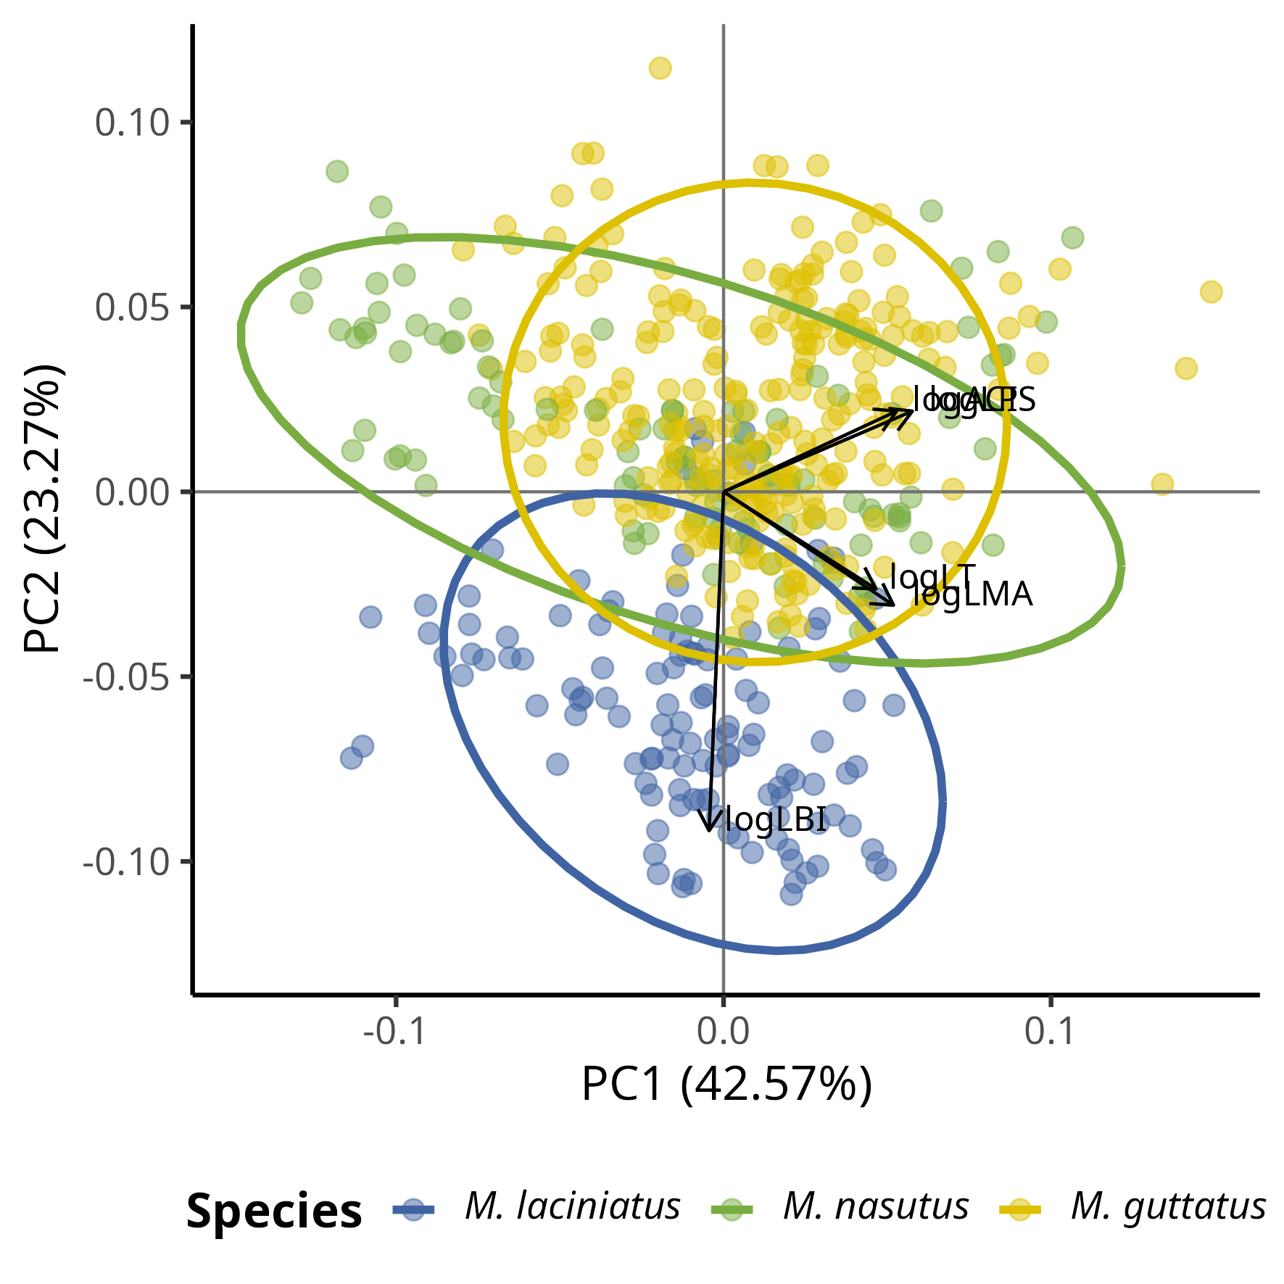

The Principal Component Analysis (PCA) shows how leaf functional traits are correlated. The PCA analyses shows correlations between ACI, LT, LPS, and LMA as loadings track along PC1 towards positive values. We observe distinct groupings by species along PC2 such that *M. laciniatus*, the most lobed species, is distinct from *M.guttatus* and *M. nasutus*. The latter two have greater overlap along PC1 and PC2.

## 12.2 Figure 2

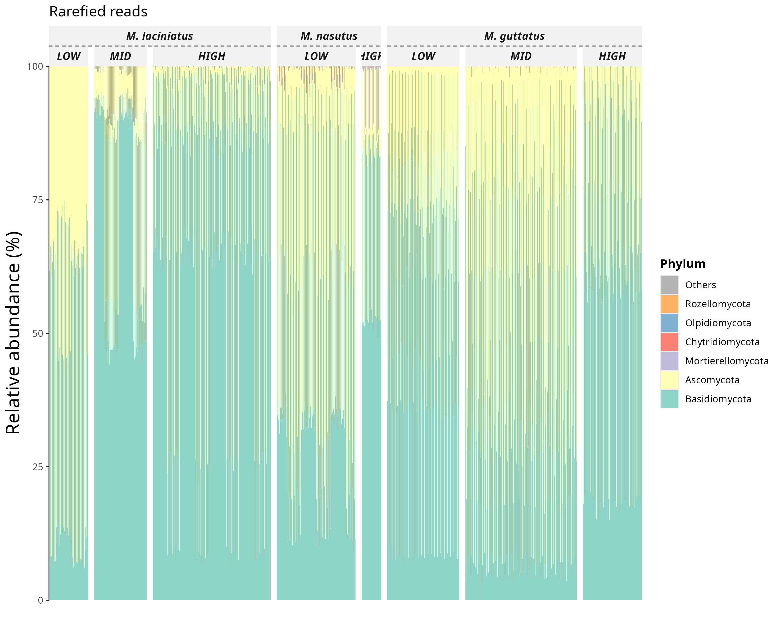

Relative abundance of fungal phyla in rarefied sequence data by species and elevation category.

## 12.3 Figure 3

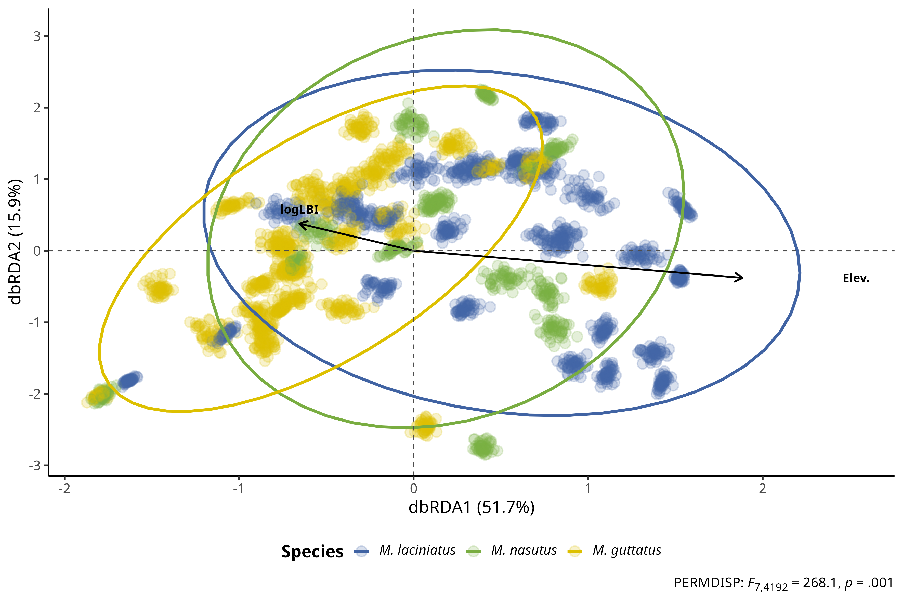

FEF community composition association with leaf functional traits and elevation per host species. Distance-based Redundancy Analysis (dbRDA) plot of rarefied FEF community and leaf functional traits by species. Each cluster of points represents a rarefied FEF community sample from one host species; blue filled squares correspond to *M. laciniatus*, green circles to *M. nasutus*, and yellow triangles to *M. guttatus*. Solid arrow lines represent significant associations (*p* < .01), while dashed lines represent non-significant associations. The length and direction of the arrows indicate the strength and direction of the association between the traits and the FEF community composition. The labels on the arrows correspond to the leaf functional traits. Ellipses represent 95% confidence intervals. The plot is based on the Bray-Curtis dissimilarity matrix.

## 12.4 Figure 4

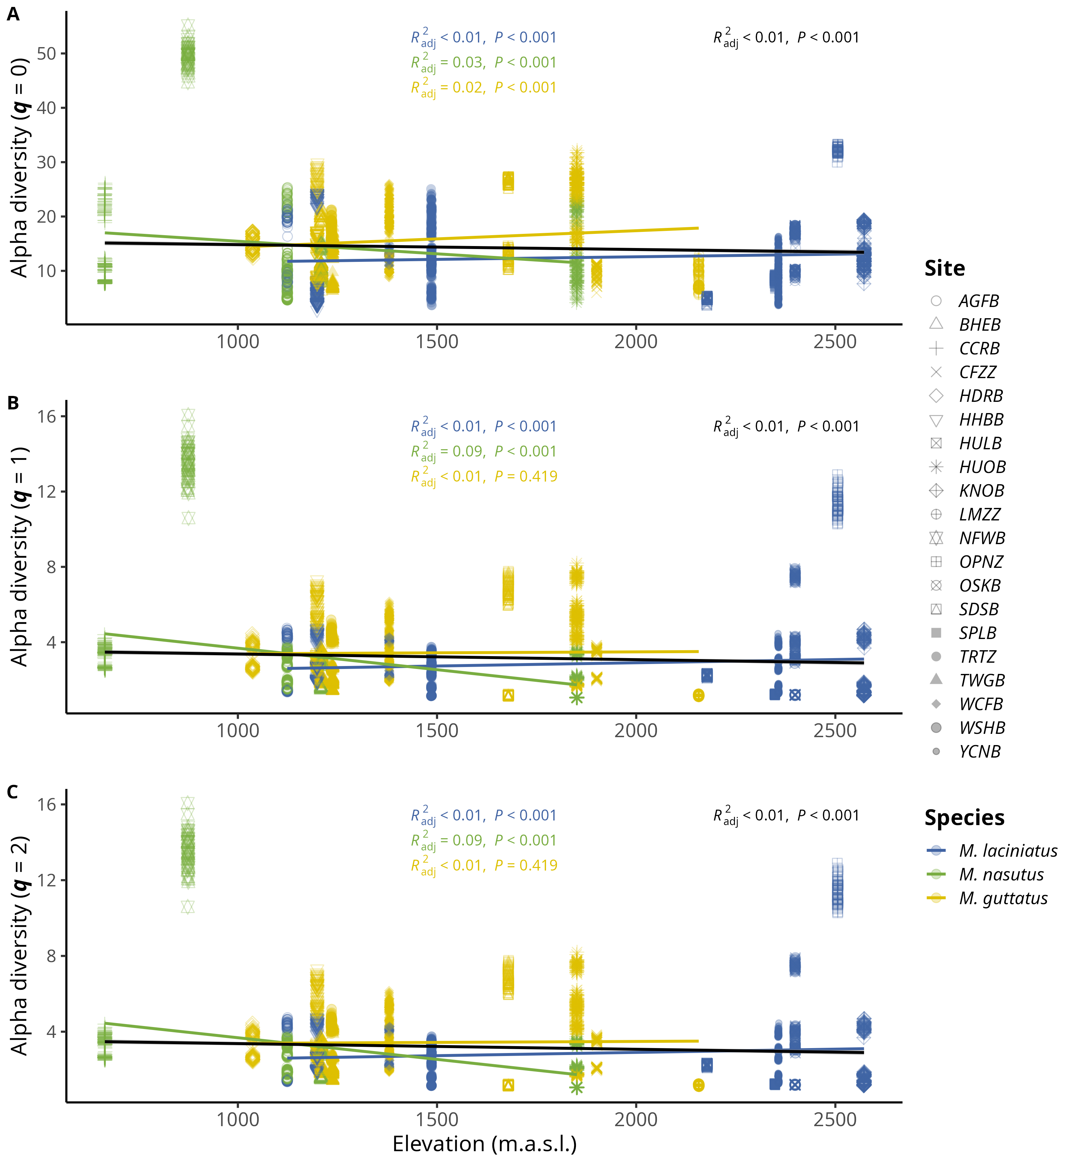

Relationship between Hill orders by host species and elevation. A) Observed ASV richness (𝑞 = 0); B) Shannon’s entropy (𝑞 = 1); and C) Inverse Simpson’s index (𝑞 = 2) per host species as elevation increases. Blue filled points correspond to *M. laciniatus*, green filled to *M. nasutus*, and yellow to *M. guttatus*. The solid line represents the linear model fit and the shaded area represents the 95% confidence interval.

## 12.5 Figure 5

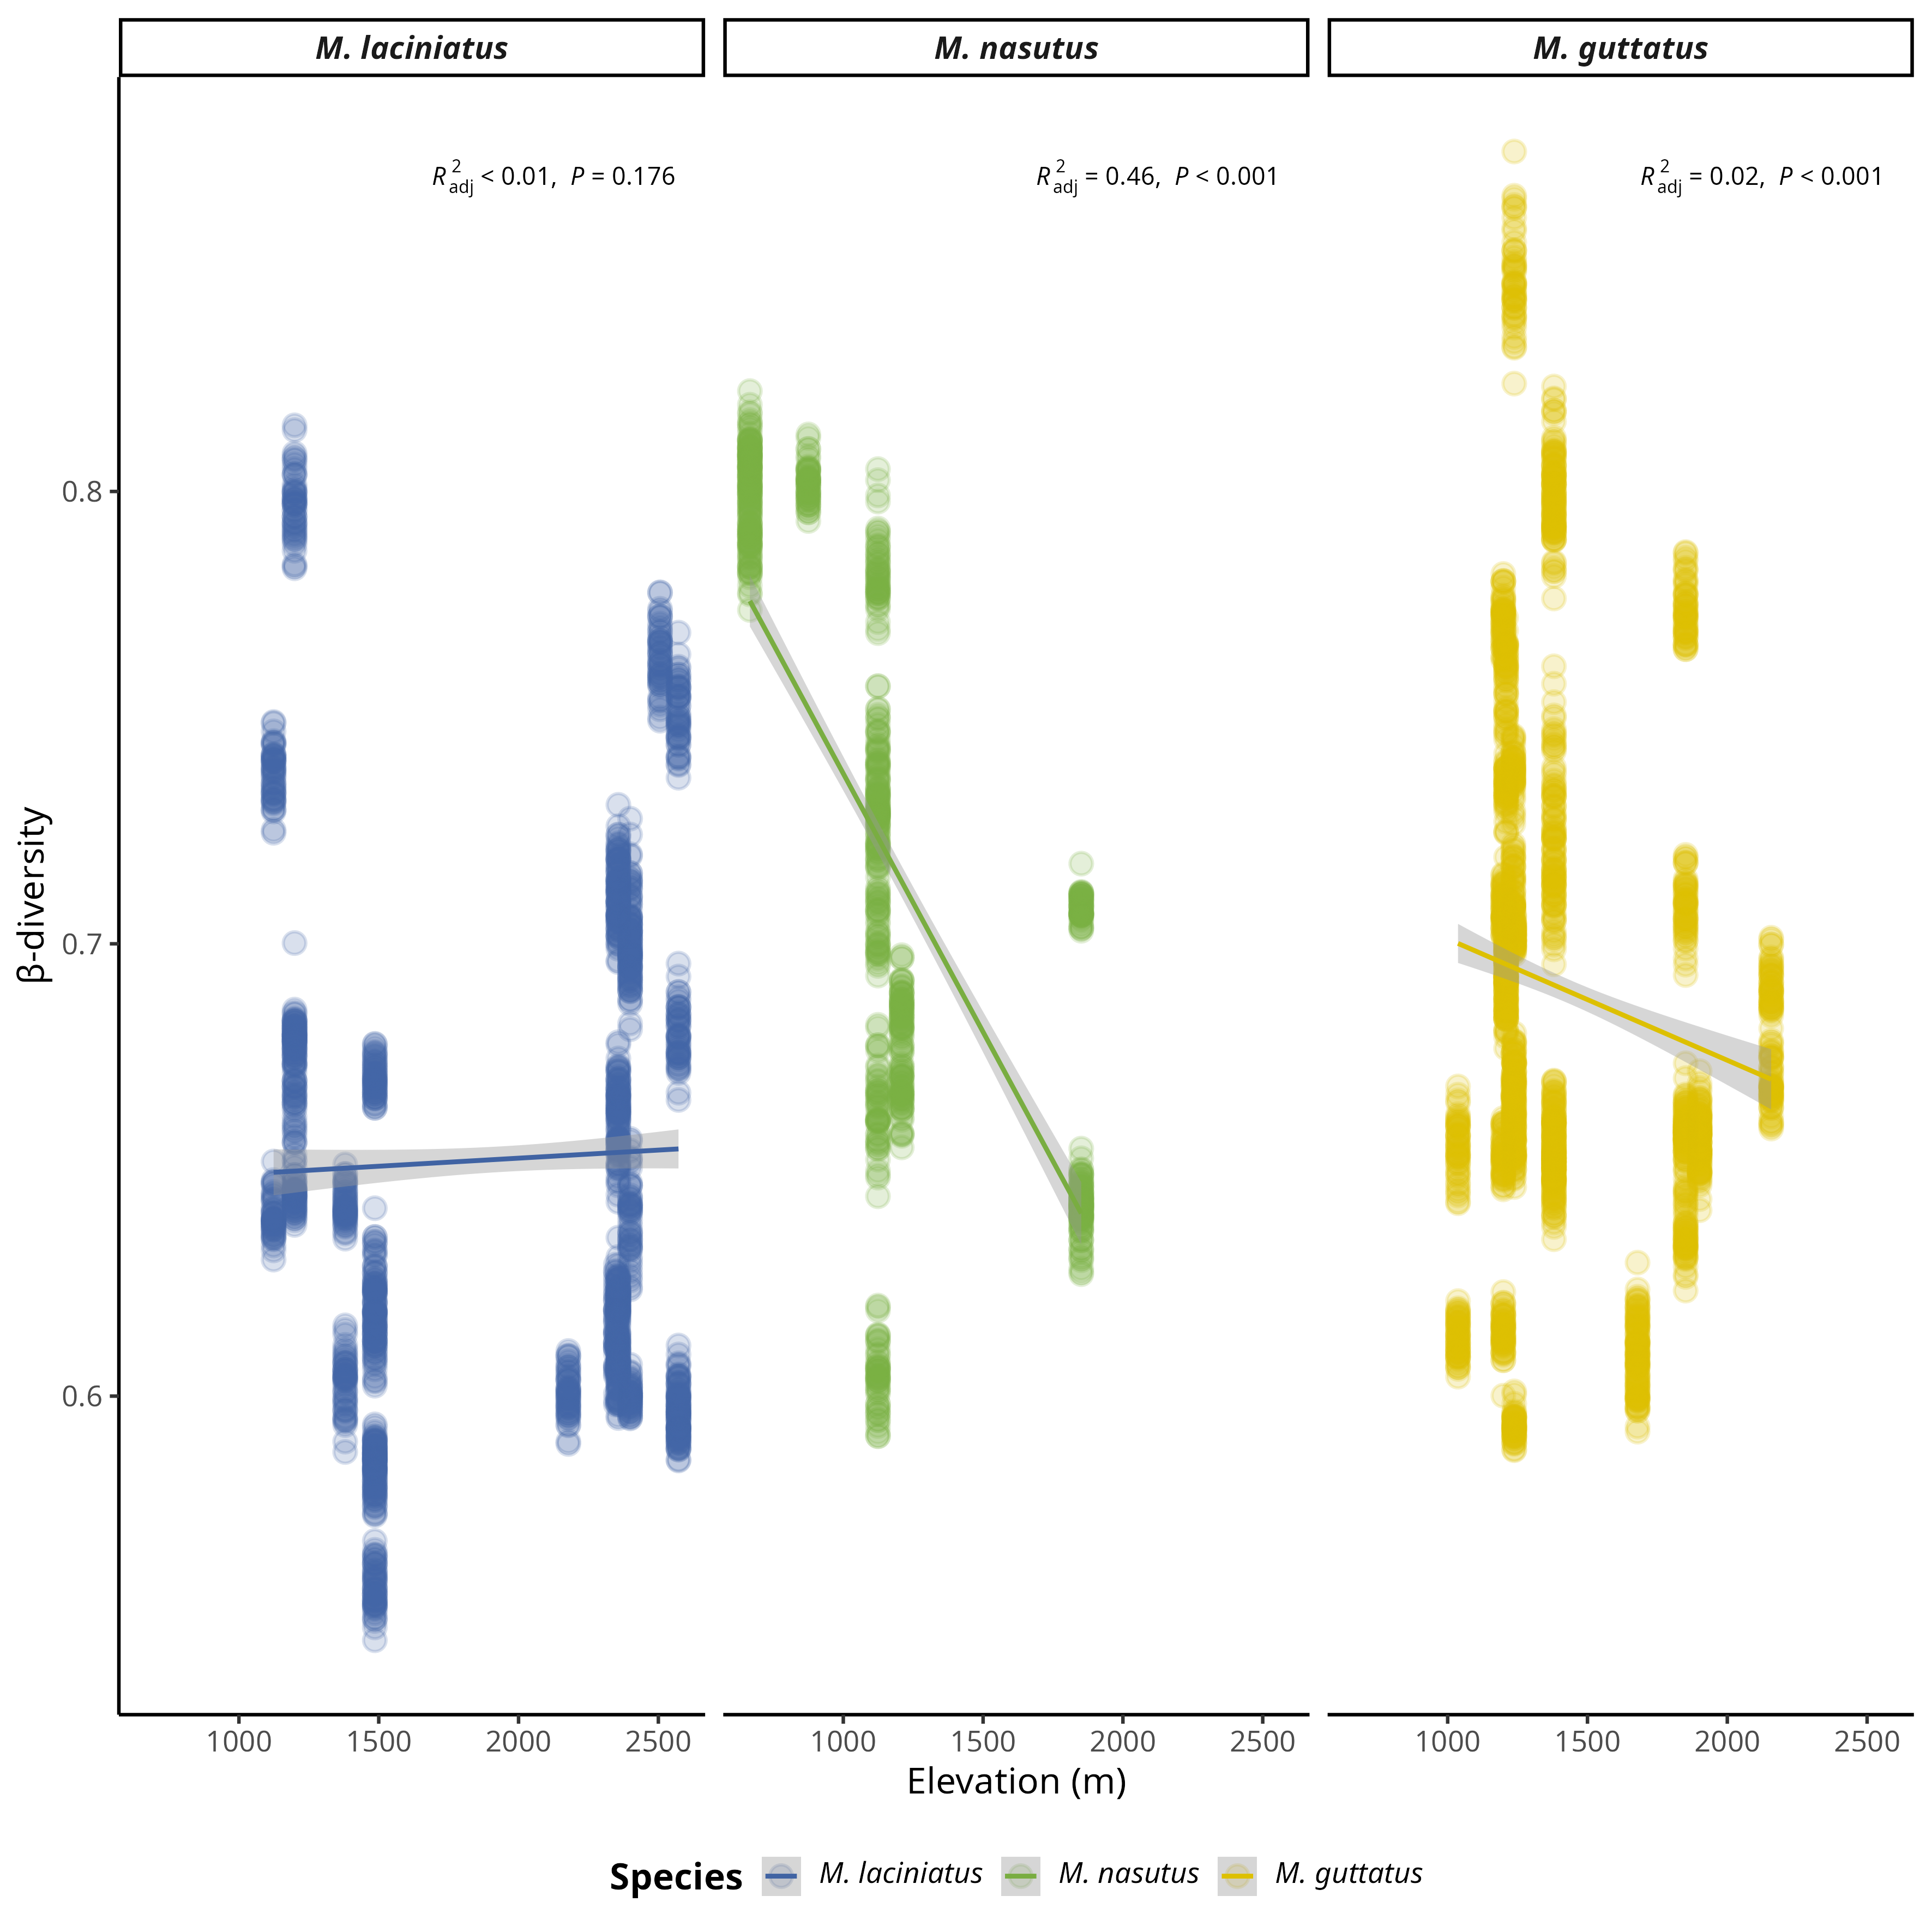Relationship between β-diversity and elevation by host species. The solid line represents simple linear regression and the shaded area represents the 95% confidence interval.

## 12.6 Figure 6

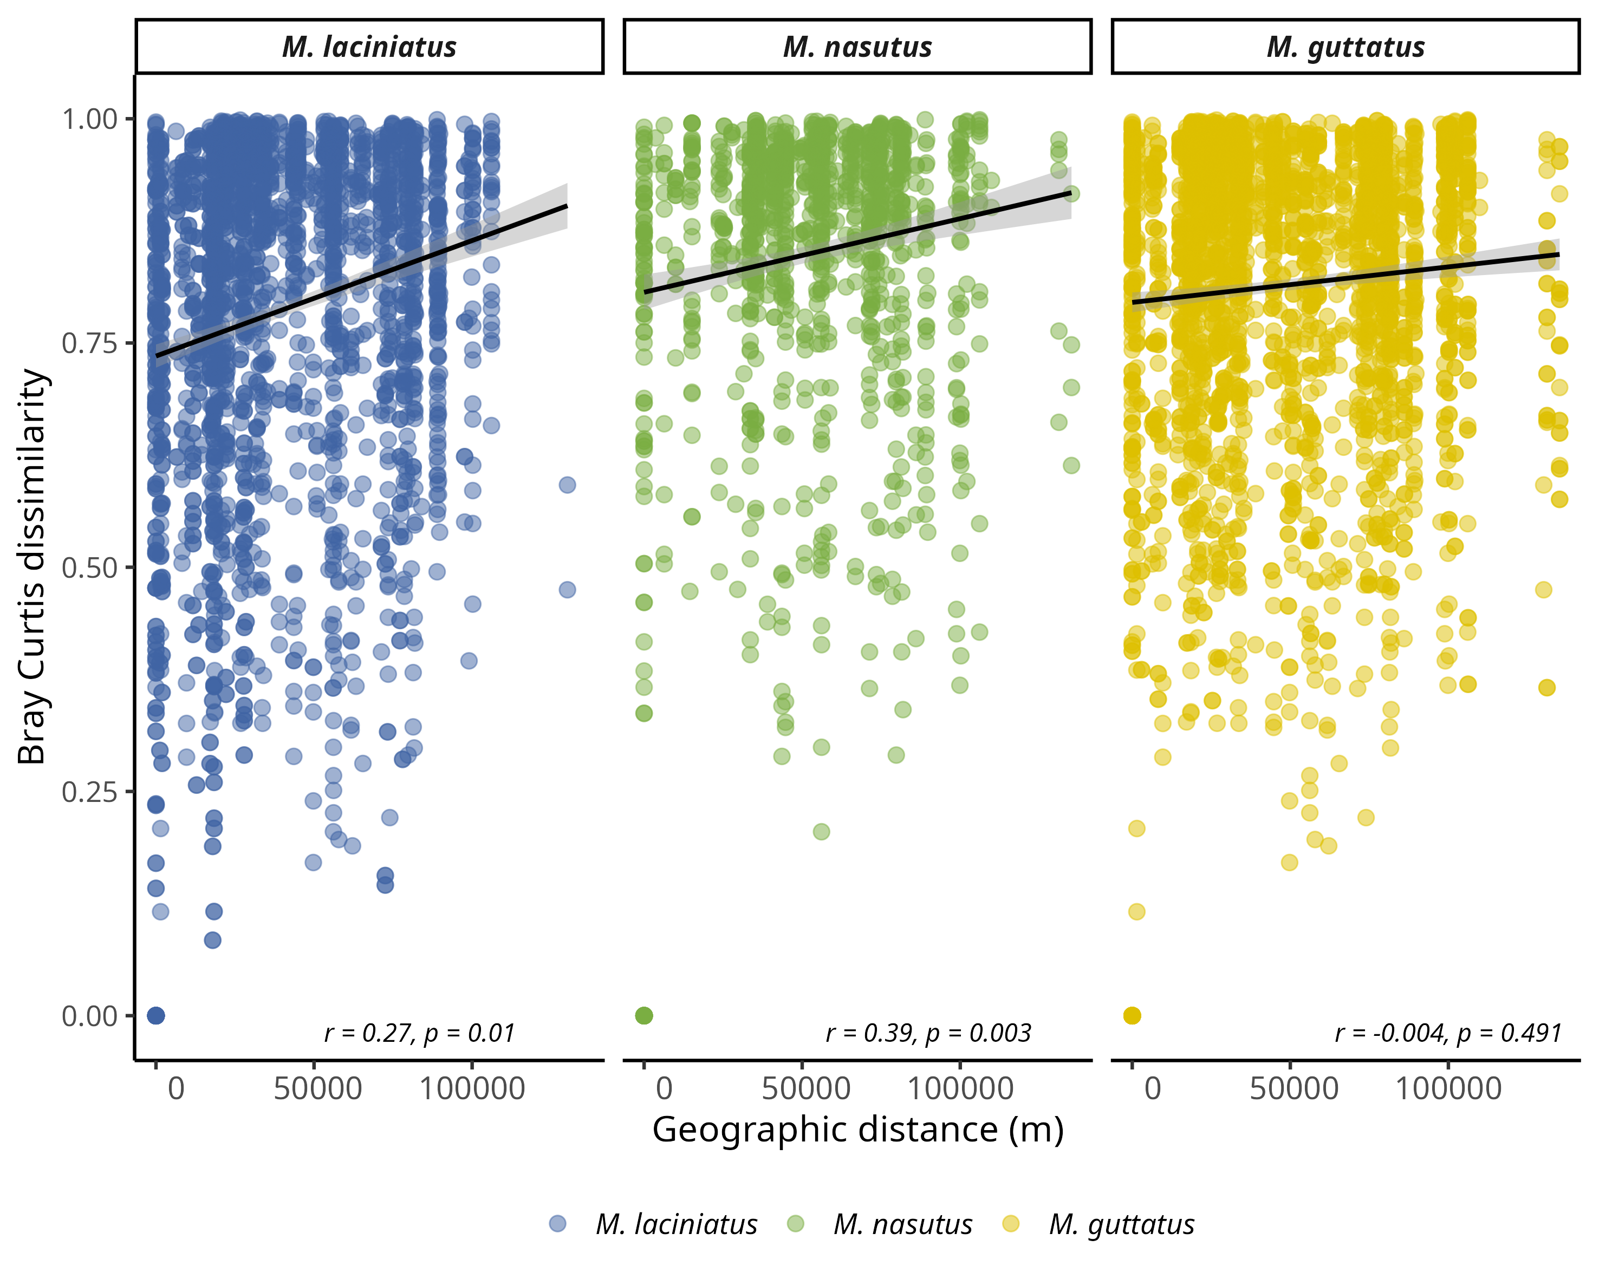

Dissimilarity of FEF communities associates with *Mimulus* as a function of geographic distance per site. Data represent pairwise Bray-Curtis dissimilarity (β-diversity) among sites. A) Fefe community dissimilarity in considering all host species. B) FEf community dissimilarity by host species. Blue filled points correspond to *M. laciniatus*, green filled to *M. nasutus*, and yellow to *M. guttatus*.

## 12.7 Table 1: Generalized linear mixed models (GLMMs) for predicting mean Bray-Curtis dissimilarity

|  |  |  |  |  |  |  |  |  |  |
| --- | --- | --- | --- | --- | --- | --- | --- | --- | --- |
|  | **Model 1** | | **Model 2** | | | **Model 3** | | **Model 4** | |
| **Predictors** | **Estimate** | **CI [t-statistic]** | | **Estimate** | **CI [t-statistic]** | **Estimate** | **CI [t-statistic]** | **Estimate** | **CI [t-statistic]** |
| Intercept | **0.589 \*\*\*** | **(0.487 - 0.691 ) [11.345]** | | **0.833 \*\*\*** | **(0.752 - 0.915 ) [20.113]** | **0.784 \*\*\*** | **(0.744 - 0.825 ) [38.057]** | **0.860 \*\*\*** | **(0.825 - 0.895 ) [48.650]** |
| *M. nasutus* | **-0.014 \*\*** | **(-0.023 - -0.005 ) [-2.933]** | | **0.016 \*\*\*** | **(0.008 - 0.025 ) [3.725]** | **0.017 \*\*\*** | **(0.008 - 0.025 ) [3.915]** |  |  |
| *M. guttatus* | **0.017 \*\*\*** | **(0.009 - 0.025 ) [4.191]** | | **0.038 \*\*\*** | **(0.030 - 0.047 ) [8.738]** | **0.039 \*\*\*** | **(0.031 - 0.048 ) [8.933]** |  |  |
| Elevation | -0.000 | (-0.000 - 0.000 ) [-1.641] | | -0.000 | (-0.000 - 0.000 ) [-1.360] |  |  |  |  |
| ACI | **0.047 \*\*\*** | **(0.034 - 0.060 ) [7.032]** | | **-0.076 \*\*\*** | **(-0.081 - -0.071 ) [-29.934]** | **-0.075 \*\*\*** | **(-0.080 - -0.071 ) [-29.898]** | **-0.078 \*\*\*** | **(-0.082 - -0.073 ) [-32.484]** |
| LT | **0.029 \*** | **(0.002 - 0.055 ) [2.139]** | | **-0.033 \*\*\*** | **(-0.044 - -0.022 ) [-5.684]** | **-0.033 \*\*\*** | **(-0.044 - -0.022 ) [-5.712]** | **-0.051 \*\*\*** | **(-0.061 - -0.040 ) [-9.508]** |
| LPS | **-0.034 \*\*\*** | **(-0.053 - -0.014 ) [-3.416]** | | **-0.017 \*\*** | **(-0.030 - -0.004 ) [-2.647]** | **-0.017 \*\*** | **(-0.029 - -0.004 ) [-2.638]** |  |  |
| LMA | **-0.044 \*\*\*** | **(-0.059 - -0.029 ) [-5.755]** | | **0.024 \*\*\*** | **(0.014 - 0.034 ) [4.829]** | **0.024 \*\*\*** | **(0.015 - 0.034 ) [4.877]** | **0.013 \*\*\*** | **(0.006 - 0.020 ) [3.743]** |
| LBI | **-0.012 \*** | **(-0.021 - -0.003 ) [-2.529]** | | **-0.010 \*** | **(-0.018 - -0.002 ) [-2.342]** | **-0.010 \*** | **(-0.019 - -0.002 ) [-2.415]** | -0.001 | (-0.009 - 0.008 ) [-0.217] |
| ***Random effects*** |  |  | |  |  |  |  |  |  |
| N | 4200 |  | | 4200 |  | 4200 |  | 4200 |  |
| logLik | 6729.854 |  | | 8154.589 |  | 8163.503 |  | 8330.814 |  |
| *AIC* | -13437.709 |  | | -16249.177 |  | -16269.007 |  | -16603.627 |  |
| Significance levels are represented by asterisks [*p* < .05 (*), *p* < .01 (**), *p* < .001 (***), and *p* < .0001 (****)]. T statistics in brackets. | | | | | | | | | |

# 13. Supplementary Material

## 13.1 Figure S1

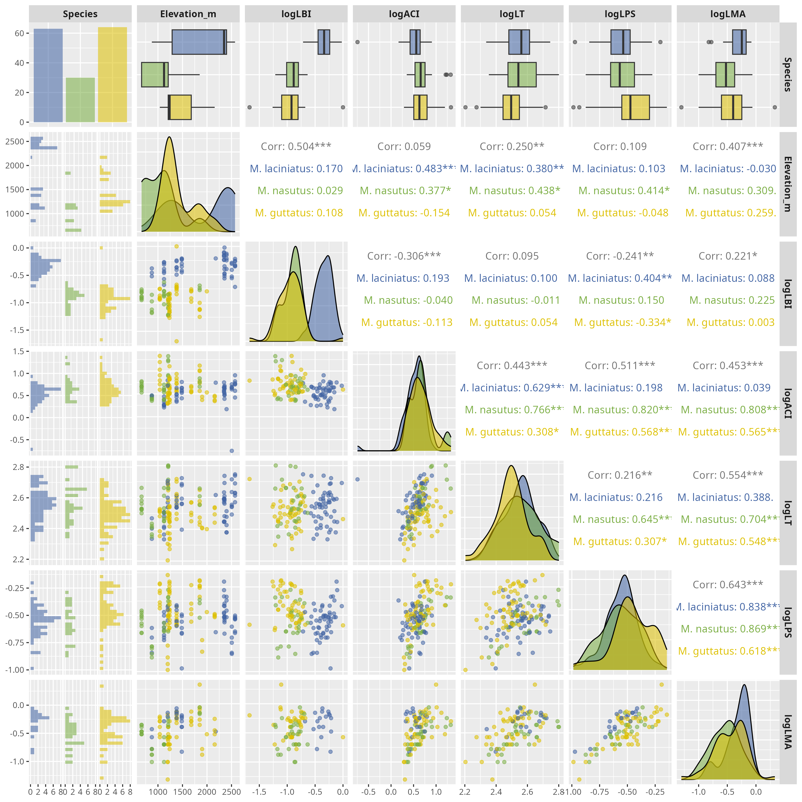

Correlation matrix of log-transformed leaf functional traits by host species. The plot is based on the Spearman’s rho. Significance levels are represented by *ns* (not significant) and asterisks [*p* < .05 (*), *p* < 0.01 (**), *p* < .001 (***), and *p* < .0001 (****)].

## 13.2 Figure S2

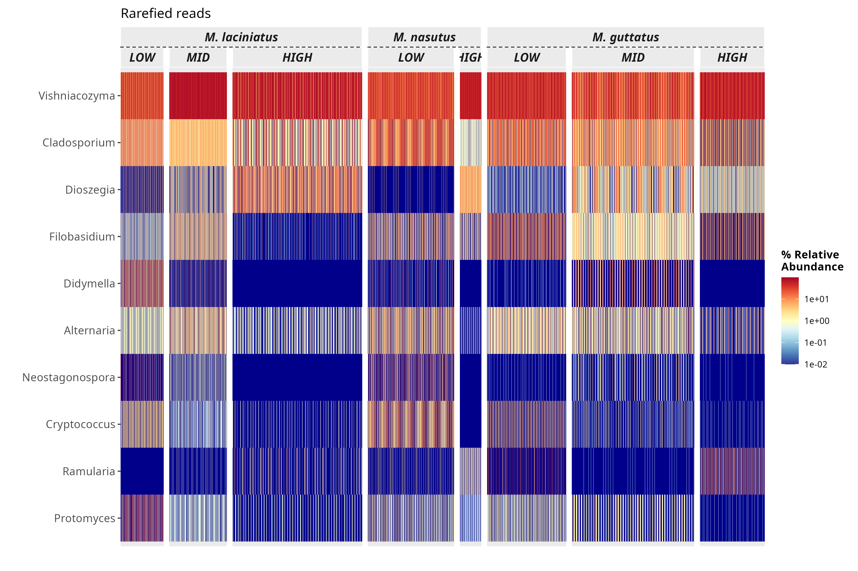

Heatmap of the top 10 most abundant FEF genera in the dataset. The heatmap is faceted by host species and elevation category.

## 13.3 Figure S3

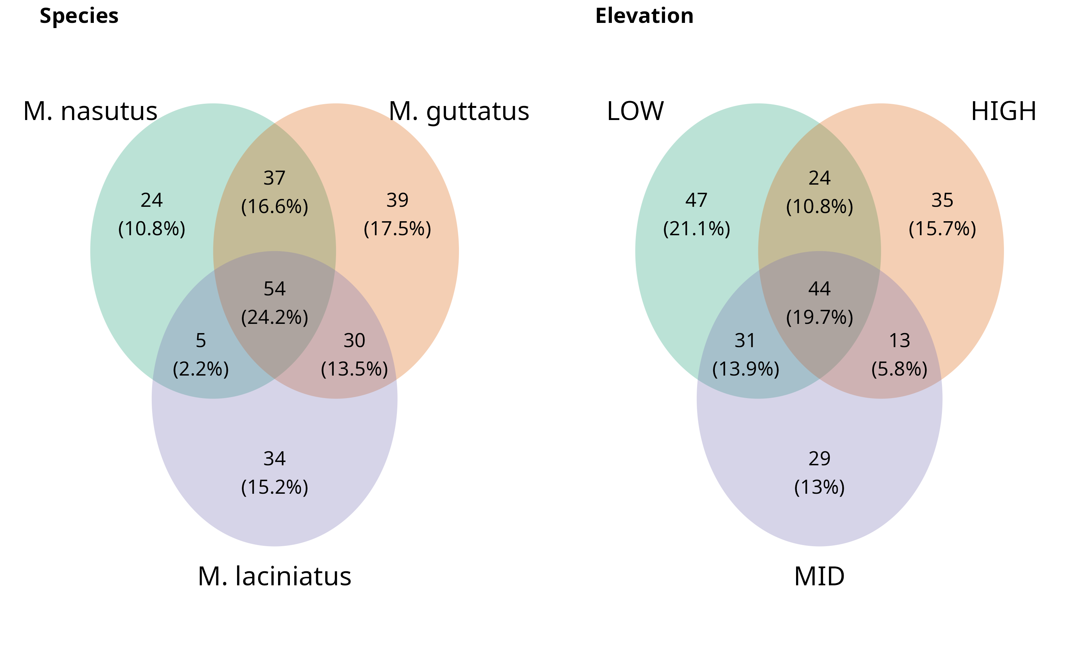

Venn diagrams of present and absense of ASVs among species and elevation categories un-rarified data and rarified data. A-B) Represent the overlap of ASVs habitat types and C-D) in gentoypes. Number of ASVs are represented the count and in parentheses as a ratio shared between genotype and habitat type.

## 13.4 Figure S4

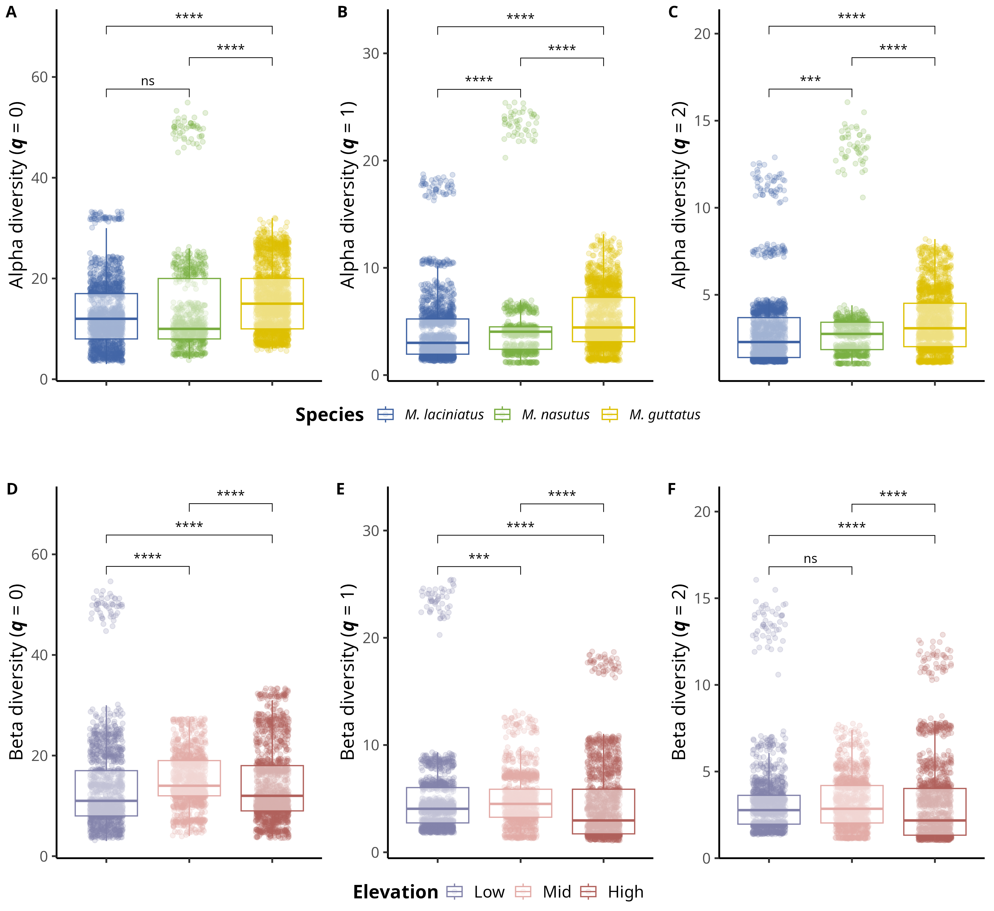

Alpha and beta diversity means comparisons in host species and eklevation categories. Alpha diversity means comparisons; A) Observed ASV richness (𝑞 = 0); B) Shannon’s entropy (𝑞 = 1); and C) Inverse Simpson’s index (𝑞 = 2) per host species. A-C) Blue filled boxplots correspond to *M. laciniatus*, green filled to *M. nasutus*, and yellow to *M. guttatus*. Beta diversity mean comparions; A) Observed ASV richness (𝑞 = 0); B) Shannon’s entropy (𝑞 = 1); and C) Inverse Simpson’s index (𝑞 = 2)per elevation category. D-F) Violet boxplots correspond to LOW elevation sites, pink filled to MID and light maroon to HIGH elevation sites, while squares represent *M. laciniatus* , circles *M. nasutus* and triangles *M. guttatus*. Significance levels are represented by *ns* (not significant) and asterisks [*p* < .05 (*), *p* < .01 (**), *p* < .001 (***), and *p* < .0001 (****)].

## 13.5 Figure S5

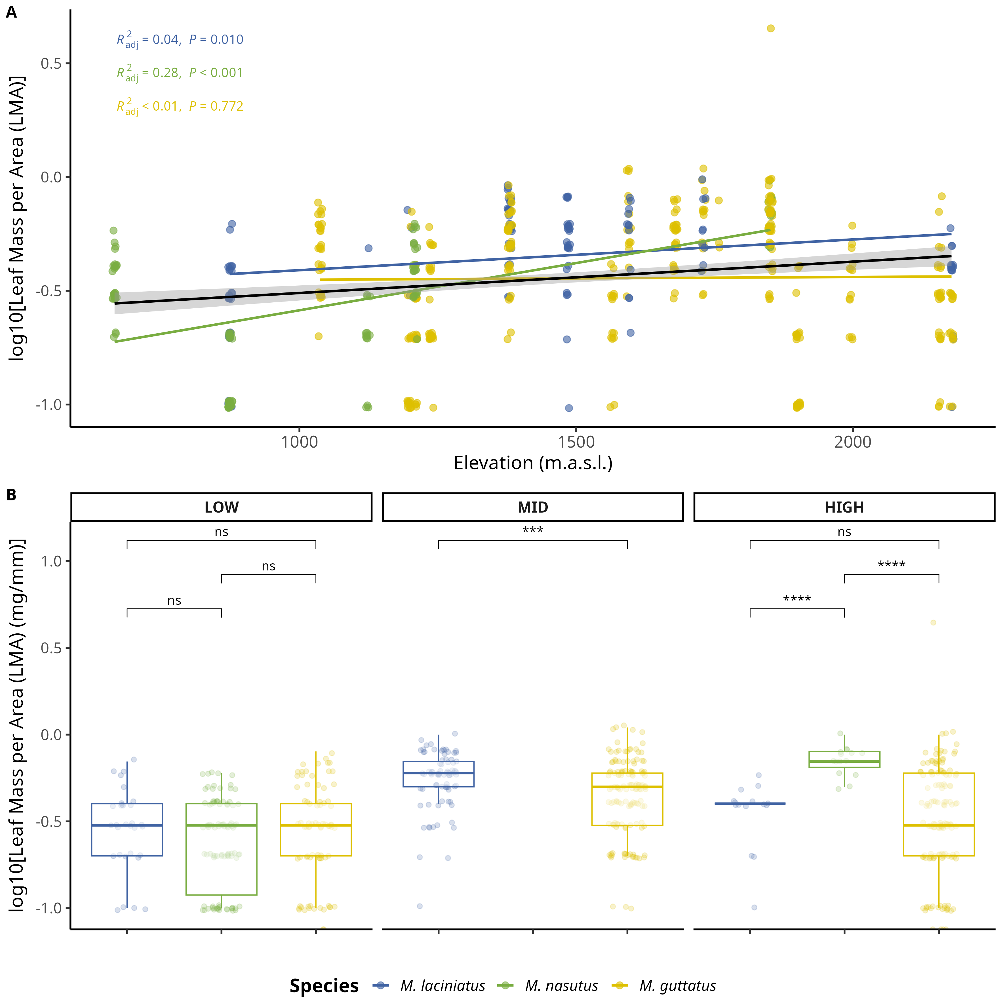

Comparison of log-transformed leaf mass per area (LMA) by species and elevation category. A) Compares logLMA means by species and elevation category: LOW (<1220 m), MID (1221 - 1828 m), HIGH (> 1829 m). The black line across violins represents the mean value. B) Change in logLMA per species as elevation increases. The black trend line represents the fitted model for all data points, see main text for *R2adj* and *p* values. Significance levels are represented by *ns* (not significant) and asterisks [*p* < .05 (*), *p* < 0.01 (**), *p* < .001 (***), and *p* < .0001 (****)].

## 13.6 Figure S6

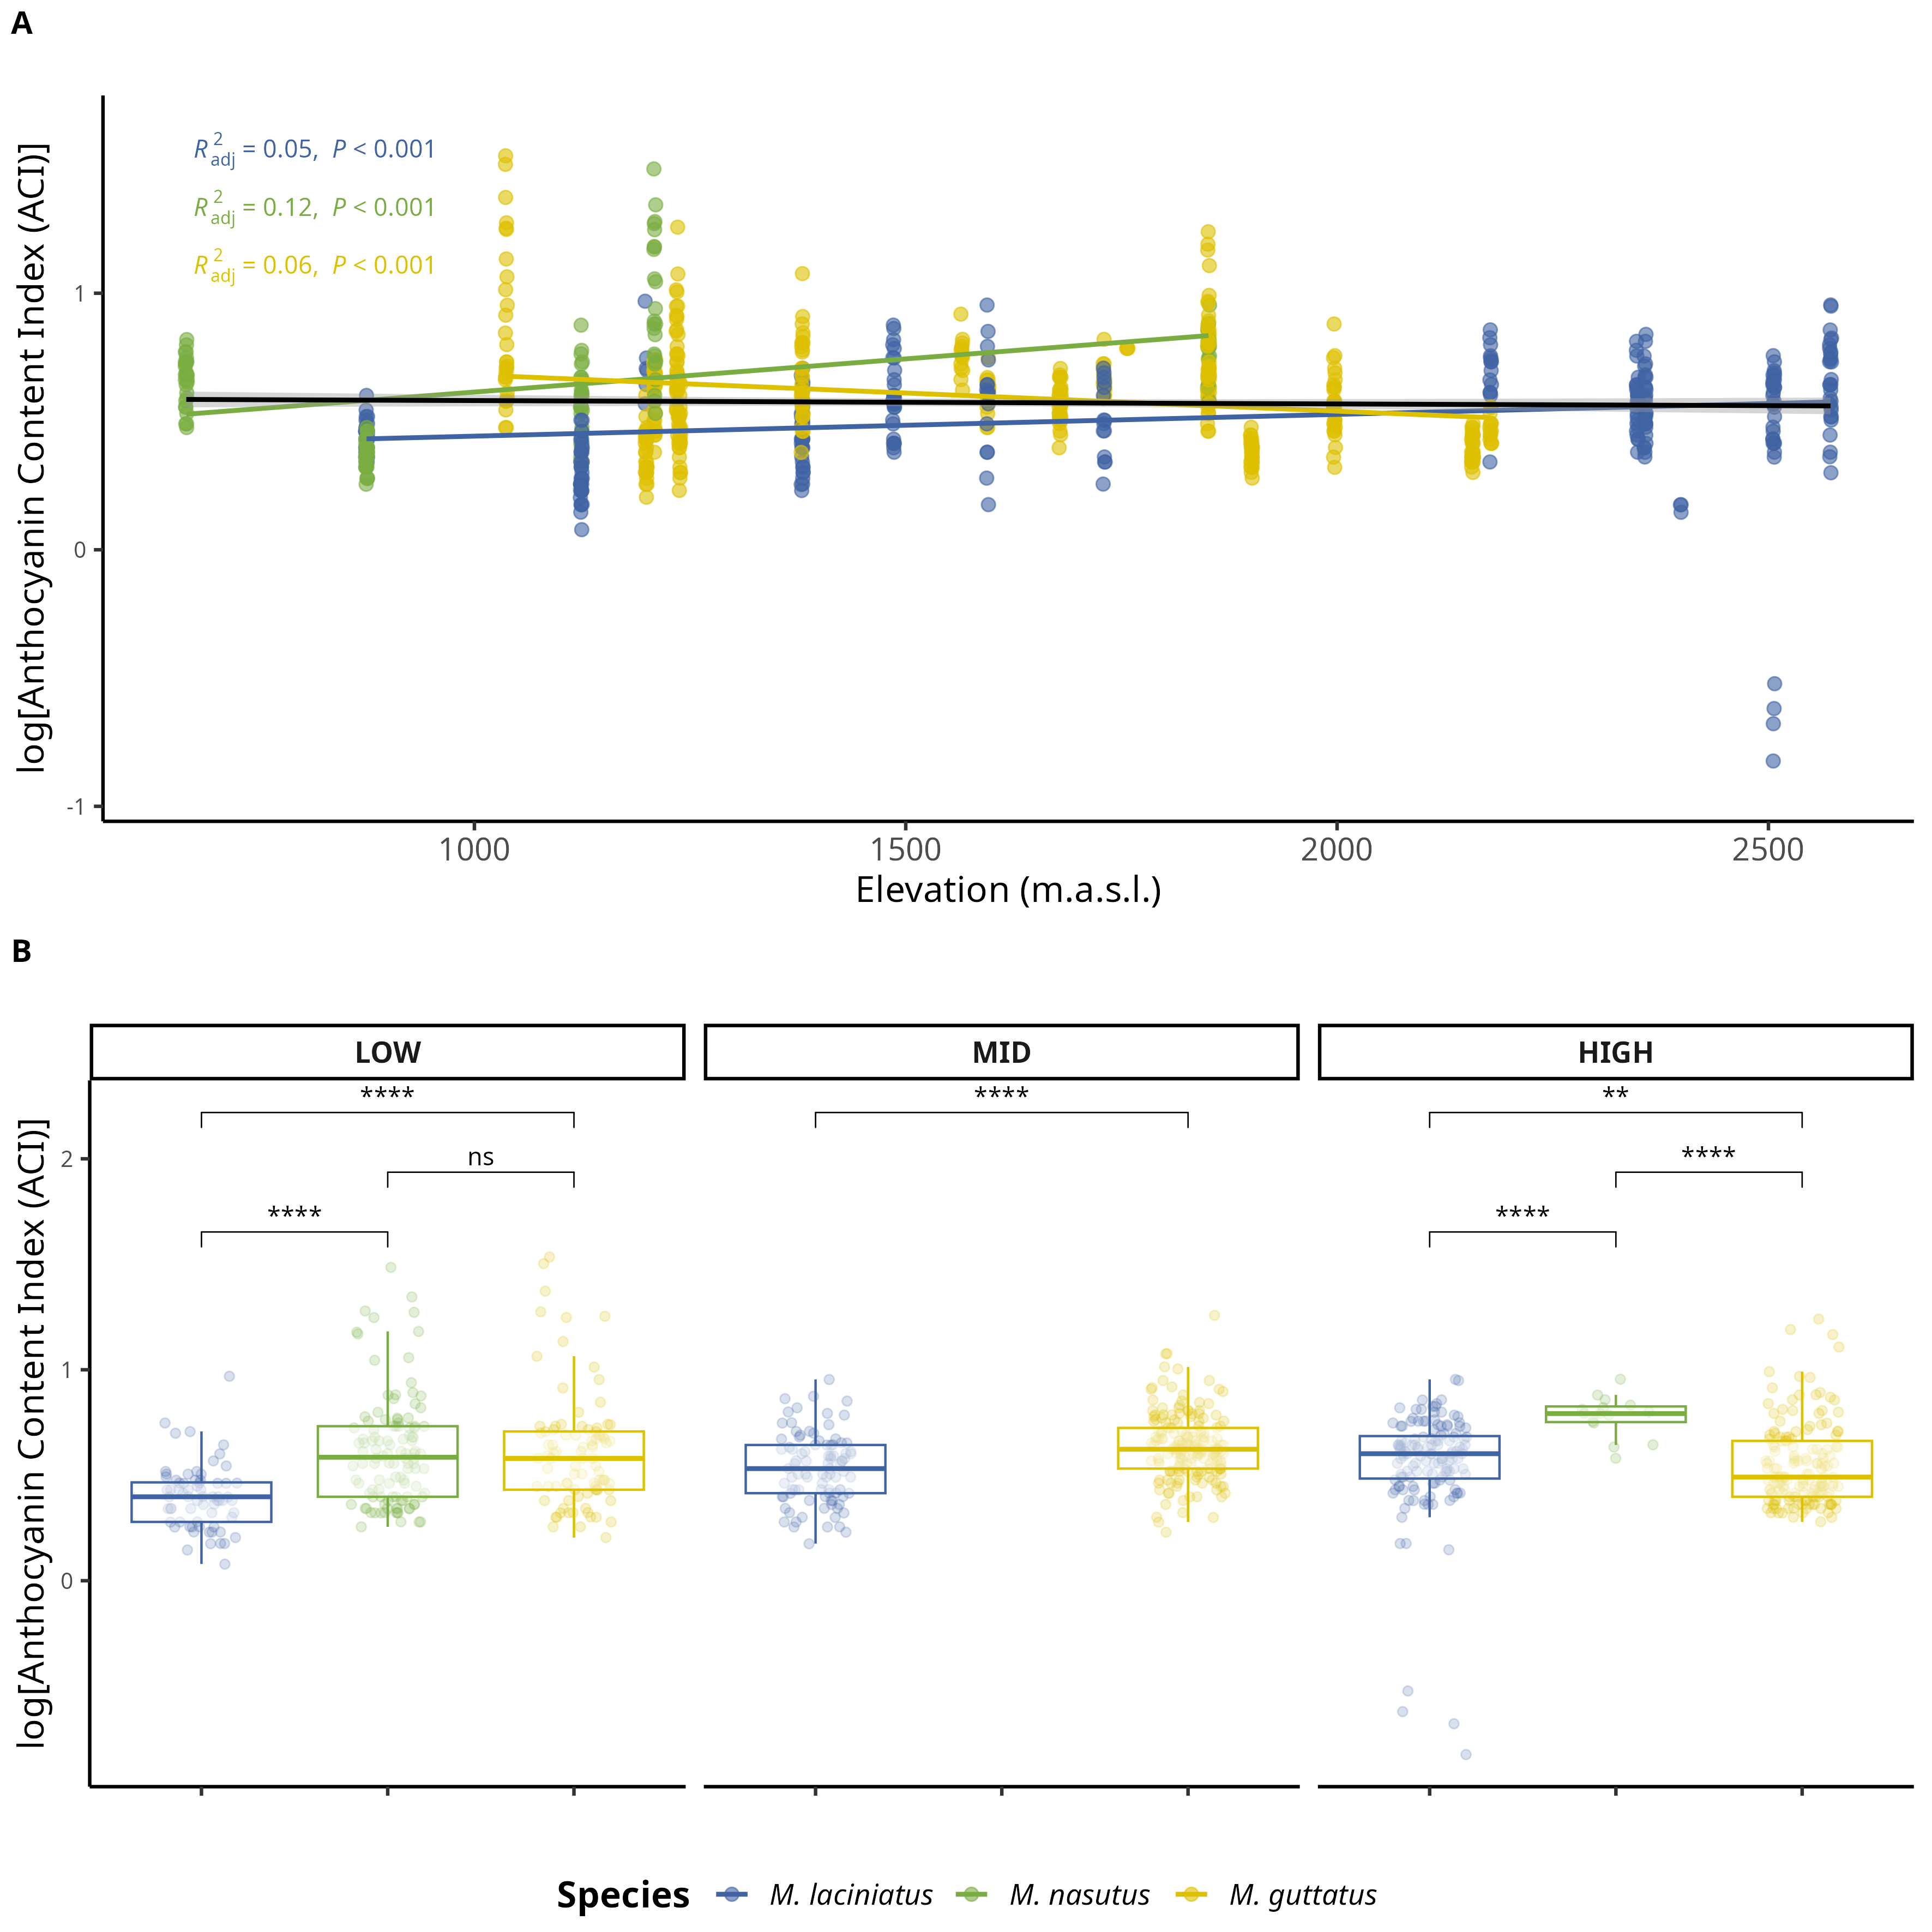

Change in log-transformed anthocyanin content index (ACI) by species and elevation category. A) Compares logACI means by species and elevation category: LOW (<1220 m), MID (1221 - 1828 m), HIGH (> 1829 m). The black line across violins represents the mean value. B) Change in logLPS per species as elevation increases. The black trend line represents the fitted model for all data points, see main text for *R2adj* and *p* values. Significance levels are represented by *ns* (not significant) and asterisks [*p* < .05 (*), *p* < .01 (**), *p* < .001 (***), and *p* < .0001 (****)].

## 13.7 Figure S7

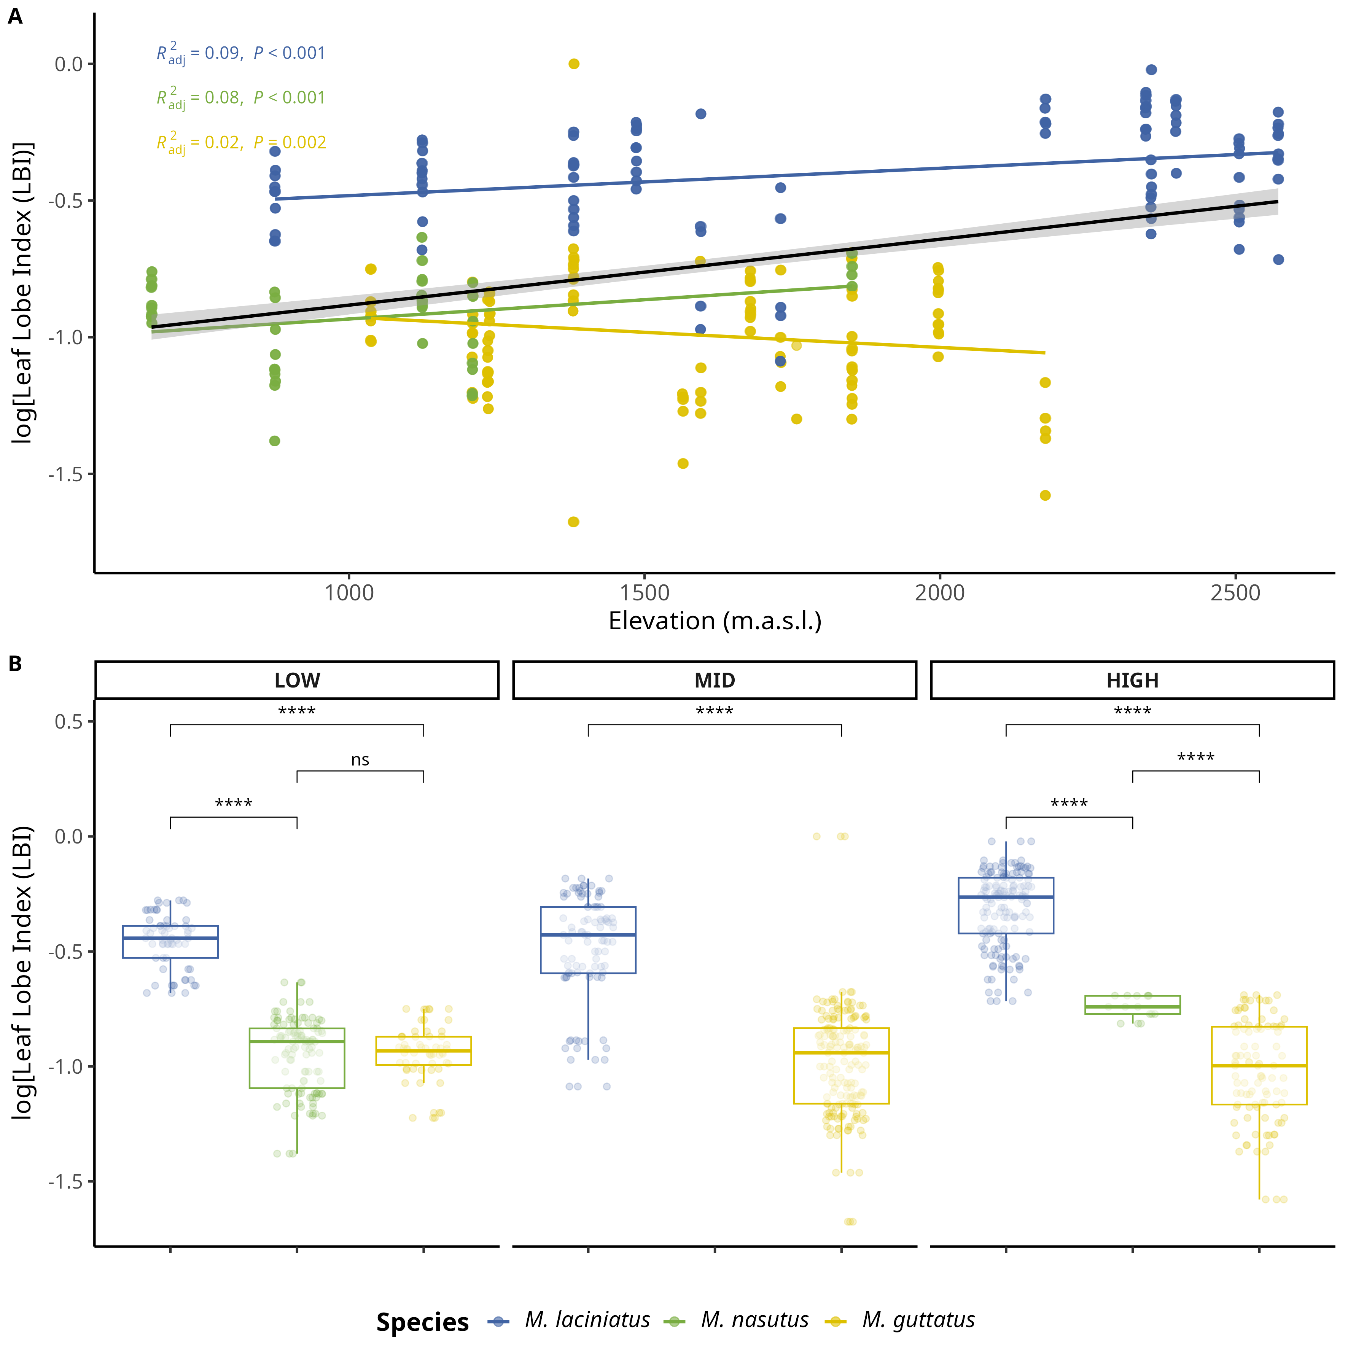

Change in log-transformed leaf lobe index (LBI) by species and elevation category. A) Compares logLBI means by species and elevation category: LOW (<1220 m), MID (1221 - 1828 m), HIGH (> 1829 m). The black line across violins represents the mean value. B) Change in logLPS per species as elevation increases. The black trend line represents the fitted model for all data points, see main text for *R2adj* and *p* values. Significance levels are represented by *ns* (not significant) and asterisks [*p* < .05 (*), *p* < .01 (**), *p* < .001 (***), and *p* < .0001 (****)].

## 13.8 Figure S8

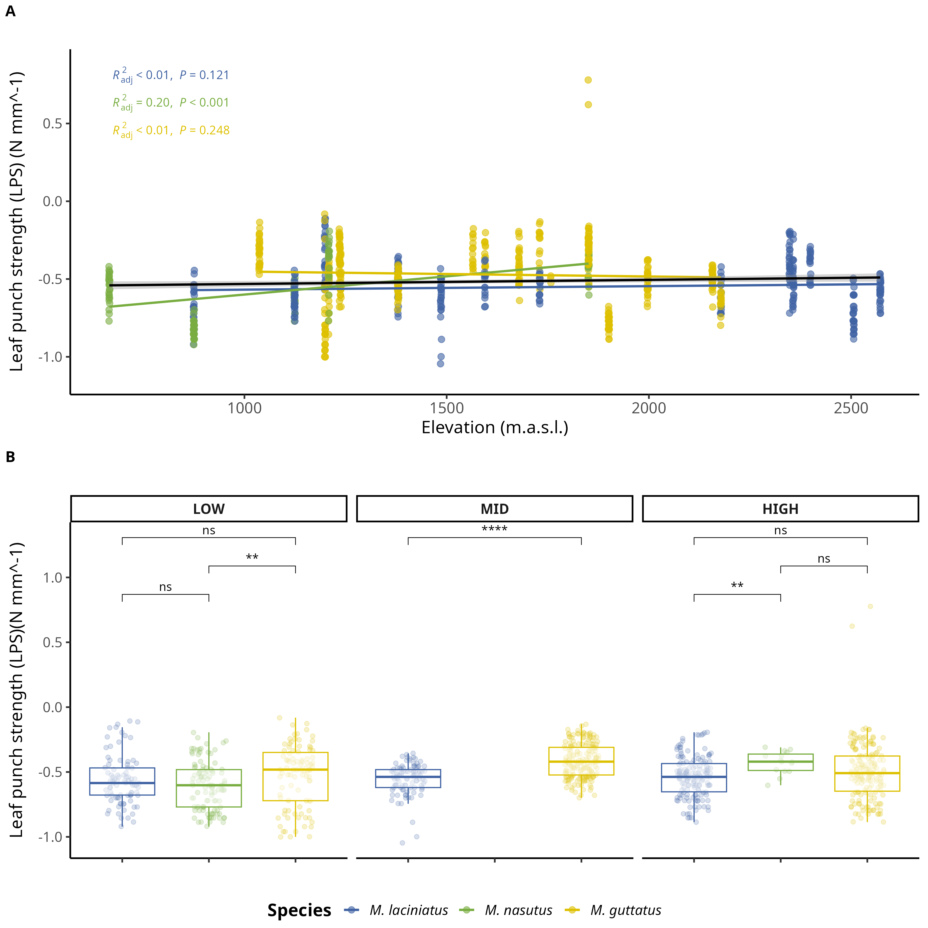

Change in log-transformed leaf-punch strength (LPS), a measure of leaf toughness, by species and elevation category. A) Compares logLPS means by species and elevation category: LOW (<1220 m), MID (1221 - 1828 m), HIGH (> 1829 m). The black line across violins represents the mean value. B) Change in logLPS per species as elevation increases. The black trend line represents the fitted model for all data points, see main text for *R2adj* and *p* values. Significance levels are represented by *ns* (not significant) and asterisks [*p* < .05 (*), *p* < .01 (**), *p* < .001 (***), and *p* < .0001 (****)].

## 13.9 Figure S9

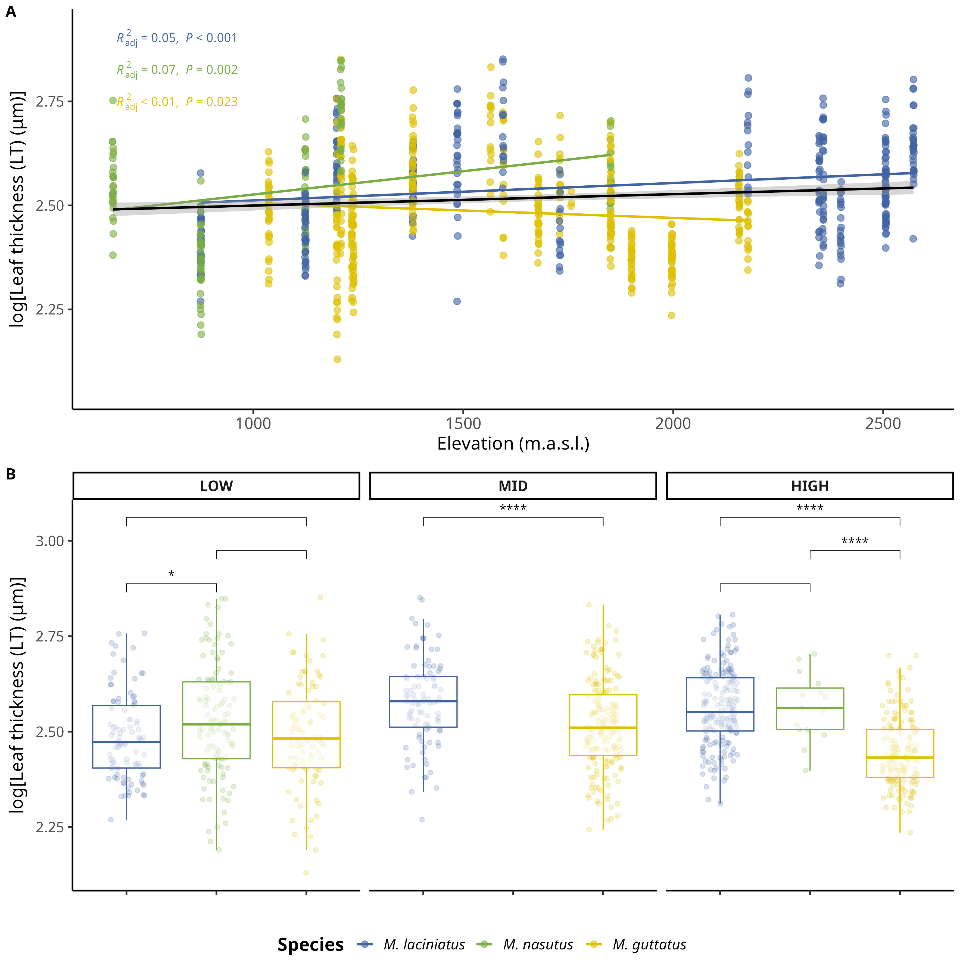

Change in log-transformed leaf thickness (LT) (𝜇m) by species and elevation category. A) Compares logLT means by species and elevation category: LOW (<1220 m), MID (1221 - 1828 m), HIGH (> 1829 m). The black line across violins represents the mean value. B) Change in logLT per species as elevation increases. The black trend line represents the fitted model for all data points, see main text for *R2adj* and *p* values. Significance levels are represented by *ns* (not significant) and asterisks [*p* < .05 (*), *p* < .01 (**), *p* < .001 (***), and *p* < .0001 (****)].

## 13.10 Figure S10

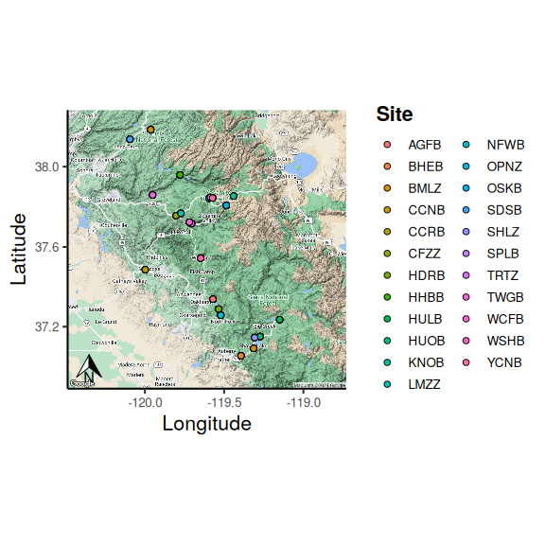

## 13.11 Table S1

Table 1: Number of individuals collected per population/site and species.

| Site | Longitude | Latitude | *M. laciniatus* | *M. nasutus* | *M. guttatus* |
| --- | --- | --- | --- | --- | --- |
| AGFB | -119.5707 | 37.33823 | 11 | 10 | NA |
| BHEB | -119.3932 | 37.05354 | NA | 9 | 10 |
| BMLZ | -119.3140 | 37.09063 | 5 | NA | 5 |
| CCNB | -119.9633 | 38.18393 | NA | NA | 12 |
| CCRB | -119.9979 | 37.48634 | NA | 9 | NA |
| CFZZ | -119.8030 | 37.75599 | NA | NA | 10 |
| FVWB | -119.7027 | 37.69859 | NA | NA | 1 |
| HDRB | -119.5347 | 37.28867 | NA | NA | 10 |
| HHBB | -119.7786 | 37.95906 | 10 | NA | 10 |
| HULB | -119.1496 | 37.23553 | 5 | NA | 5 |
| HUOB | -119.2735 | 37.15072 | NA | 5 | 17 |
| KNOB | -119.4404 | 37.85385 | 10 | NA | NA |
| LMZZ | -119.7727 | 37.76778 | NA | NA | 10 |
| LYFB | -119.6014 | 37.74882 | NA | NA | 5 |
| NFWB | -119.5214 | 37.25740 | 10 | 10 | NA |
| OPNZ | -119.4863 | 37.80723 | 20 | NA | NA |
| OSKB | -119.5946 | 37.84269 | 7 | NA | NA |
| SDSB | -120.0946 | 38.13619 | NA | NA | 10 |
| SHLZ | -119.3074 | 37.14513 | 5 | NA | 5 |
| SPLB | -119.5861 | 37.84719 | 9 | NA | NA |
| TRTZ | -119.7053 | 37.71610 | 10 | NA | NA |
| TWGB | -119.9513 | 37.85882 | NA | NA | 9 |
| WCFB | -119.7191 | 37.72359 | 11 | NA | 12 |
| WSHB | -119.6479 | 37.54334 | NA | NA | 12 |
| YCNB | -119.5728 | 37.84390 | 10 | NA | NA |

## 13.12 Table S2

Table 2: Prevalence of phyla in samples per species.

| Species | Phylum | Ocurrance |
| --- | --- | --- |
| *M. laciniatus* | Ascomycota | 57 |
| *M. laciniatus* | Basidiomycota | 62 |
| *M. laciniatus* | Mortierellomycota | 2 |
| *M. laciniatus* | Olpidiomycota | 2 |
| *M. nasutus* | Ascomycota | 29 |
| *M. nasutus* | Basidiomycota | 27 |
| *M. nasutus* | Chytridiomycota | 2 |
| *M. nasutus* | Mortierellomycota | 2 |
| *M. nasutus* | Rozellomycota | 2 |
| *M. guttatus* | Ascomycota | 58 |
| *M. guttatus* | Basidiomycota | 63 |
| *M. guttatus* | Mortierellomycota | 2 |
| *M. guttatus* | Olpidiomycota | 1 |

## 13.13 Table S3

## 13.14 Supplementary methods

### 13.14.1 Illumina TruSeq adapters

The modified primers for the first PCR (adapter ligation and ITS1 amplification) were as follows: 5’-CAC TCT TTC CCT ACA CGA CGC TCT TCC GAT CTC TTG GTC ATT TAG AGG AAG TAA-3’ (forward) and 5’-GTG ACT GGA GTT CAG ACG TGT GCT CTT CCG ATC TGC TGC GTT CTT CAT CGA TGC-3’ (reverse). See (Gardes & Bruns, 1993) and (White et al., 1990) for more details.